Samuel Brandenburg

Mini Fast Food Ordering System

Written by Samuel Brandenburg

# Brief description of program

For my term One project, I have decided to simulate a small graphical interface that allows users to order meals. My original idea was to create a complete restaurant management system, but it would be to time consuming to complete all of its functionality I decided to change the theme to an ordering system. The program has four different graphical user interfaces. The first interface asks the user to enter his or her username and password. If the user does not have an account, the user must then select to create a new account which then a new graphical user interface layout will appear. The user then must enter their full name, a username, and password. Once the form has been completed successfully the user will be brought back to the user login layout. Once they have successfully logged in the layout will change again to a menu that allows the user to go back to the login layout or exit the program. The last layout contains the options to take customers’ orders. The user will be able to change between the two different layouts by pressing one of the two buttons on the left-hand side. This program present a basic principle of setting up a digital ordering system for a fast food company. While the program has limited functionality, it can be expanded to have more complex operations.

Analysis of Requirements.

For this python project, I have exhibit all the information taught in term One and more. The program contains if-statements and nested decision statements that check to see if all the required requirements have been met. The program also uses loops. For example, I use a text file to maintain all the users of the program. The user will need to have an account and login in with tbheir user name. For this process to be completed I use multiple decision statements and a for loop to iterate through the text file. The program then writes new information to the file without overwriting previously added content. I used a tuple to help me get the exact location of the username and compared it with the new username to be entered. This process makes use of multiple things taught during term one including file manipulation. Other things that my program makes use of is dictionaries classes, inheritance, Tkinter, and widgets. I also focused on making error correction measures. This will let the program handle errors gracefully. The dictionary used acts a four-dimensional array. I also focused on using the camel notation when naming variables.

Program Design

I decided to use Tkinter a python library used to create Graphical User Interfaces(GUI) for programs. This project also uses two separate classes. One contains all the graphical widgets to create the different GUI’s. The other class contains methods that achieve separate functionality. I originally created the program without any structure to get an understanding how Tkinter works and how to get it to do exactly what I wanted. In this report I will break down the several different groups of coding in a sequential order explaining my logic and understanding.

In order for me to get access to the widgets in the Tkinter class, I first had to import Tkinter in my program. I then had to use object referencing to give a variable permission to access Tkinters’ functions. I then had to create an object of type GUI and pass the object “root” that reference the Tkinter class inside the GUI class as a parameter. My last step was to call the mainloop method to keep the program in an infinite loop to respond to events while the program is running. The two classes I created are labeled GUI and Functionality. I will first break down the GUI class as it is the main thread of my program. The class inherits the Frame widget and it also inherits the Functionality class. Inside the GUI class I have five local variables. My variable labeled “customFont” is a tuple which has two data types a type string and a type int. I created this variable to customize the font for all my labels and buttons on the interface. My second reason for making it a variable is to make adjusting font types and sizes easier. The other three local variables are used to change the default appearance of the layout. The last local variable is used to help switch between the home screen layout and the order layout. My first method I used was a constructor that provides the initial values to my object. Since I inherited frame, I needed to pass the Tkinter object named root to the Frame class. In order to do this I needed to use the keyword “super” and the name of the current class followed by the dot operator and call its constructor method. This tells the compiler that you are asking for the super class which is the Frame class. Each method must have “self” labeled as the first parameter. This refers to the object accessing the attributes in the class. Once I finished creating the Frame I then refer to the object of GUI as “self” and call the grid method. The grid method is used when you want to display a widget of Tkinter. It is also formally known as the grid manager. The following I have just explained will create a blank window which will appear when you run the program.

# Structuring of My Methods in The GUI Class

I wanted to focus on structuring my program on the object-oriented principles; therefore, the GUI class contains nineteen different methods. The first method to be called is labeled “login_interface”. Each layout is inside its own method and they have their own local widgets; such as, buttons, list, entry and drop down list. My reasoning behind this approach is to make it easy to swap from one layout to the next. I also focused on making the code readable by using purposeful names. I tried to avoid using the keyword “global” in my program, but because of the way I structured the code I needed to use it three times on the widgets that act as a container for the local widgets of each graphical layout. I made these variables the container to give me access to each different layout so I can remove and add them to the main frame. The “login_interface” is first method to be called. Inside this method, I created a Frame object and added the local widgets for this layout inside the Frame object. To create this Frame object, I needed to add the parameter self that refers to the specific object and I used the keyword “bg”. The keyword “bg” is an attribute in the Frame class and the other widgets that allows the creator to change the background color. I initialized this attribute with the local variable named “color” which has the color in hexa-decimal format. I then created the widgets I wanted to use to make up the login layout. Many of the attributes I focused on was to format the widgets and customize its appearance. Therefore, each widget has parameters for when the object was initialized and when customizing its grid position. The attributes I mainly focused on was its positioning. In order to get its appearance, I used the attributes row, column, padx, and pady. The attributes row and column allow you to place the widget on the frame; however, you will need to use padx, and pady to get the right appearance. The reason for this is because there is default margin placed between each widget. This will make it difficult when trying to create widgets that have no gaps in between them. Padx means padding this attribute takes two values that places padding on its right side. left side, or both. Pady places padding on the top and bottom of the widget. On the login_interface layout it has three buttons which are given events when pressed. When passing parameters to the methods that handles the event I used the lambda expression. If I don’t use this expression it changes the format of the layout or it doesn’t activate the event when the button is pressed. The reason for this is that when the program is compiled the way the code is written causes the method to be called without an event. Therefore, I use the lambda expression because it only fires the event when the button is pressed. When there’s no parameters needed for the method the lambda expression is not needed. One of the buttons on this layout allows the user to bring up a different layout that takes in new user information to create an account. This method is called “bring_up_signup_interface” that takes a parameter. The parameter I decided to pass in this method is the container for the login interface layout. The reason behind me passing this parameter is to avoid using the global variable and to allow a method outside of its scope to gain access to this variable. Once this variable is passed I used the method “grid_forget()” to remove the login layout, and I called the “signup_interface” method. Once this method is called a different graphical layout appears. This interface ask for the users full name, account name, and password. This layout has two buttons one is to cancel the sign-up process and go back to the login interface. The other button allows the user to submit the information entered to create a new account. Before this process is completed I created measures that forces the user to fill out the full form. Also, I made sure that the password the user picks is confirmed. If the two passwords don’t match an error will appear and prompt the user that the passwords don’t match. Other measures I created was to make sure that there is only one username of its type. If the user enters a name that already exist, the new account will not be created and the user will be notified that he or she needs to change the username. Once all the requirements have been satisfied the users information will be written to the text file. This text file will act as the database for my program. The submit button is attached to the “new_account” method that takes in all the parameters of the form. Inside this method is the algorithm that implements the measures mentioned above. To accomplish this logic. I used multiple “if-statements” nested within each other. I also use a variable of type Boolean that doesn’t change to true until all the requirements are satisfied. If all the requirements are satisfied it calls the “add_to_database” method that takes in all the parameters that was previously passed. The “add_to_database” method writes the information to the text file. I first read the contents that are already in the file I then use a for loop to iterate through the list and compare it with the username entered to be created. If the username is already in the text file the user will be notified to change their username. If it doesn’t exist I create an object of type file that opens the file and writes the information to the text file without overwriting the previous information. The file objects created will then be closed because it is good practice. The user will then be brought back to the login layout. If the user enters either the wrong username or password a pop up message will appear and tell the user invalid request. Once the user enters the correct username and password the layout will change to the front screen of the program. This screen has two buttons that have been modified in appearance and given events when pressed. The first button is labeled “Go back to login” and the other button is labeled “Clock Out”. The first button brings the user back to the login screen. The other button exits the user from the program. To the far left are two more button stacked on top of each other. These buttons control which layout will be placed in row zero, column one. The button labeled “orders” will change the layout, so that the user can take customer orders. I created dropdown box that has different categories of food. I used an “OptionMenu” function to create this widget. The user must select an item to add to the “ListBox” named cartList. If the user doesn’t select a meal and quantity amount they will not be able to add the item to the cart. Once added to the cart the labels at the bottom will change to reflect the price for the items in the cart. I used a dictionary within another dictionary to get the pricing for each item. Once the user is ready to pay for the meal they will need to hit the button labeled “done” the Entry object that takes the payment enables. If the user enters an amount equal to or greater than the order amount the labels will update to show how much change the user gets back. If it is less than the amount the payment will not be taken, thus the customer can then remove items from the list to make it more affordable. Once the payment has been completed the cashier will need to press the reset button that resets all the values and another order can be taken.

Test Cases

The program has been completed so all the problems I encountered will be documented in the critique section.

1. Test Case 1 trying to enter the program without entering a user name or password.

Expectations: I expect that a message box appears prompting the user cannot gain access to the other layouts.

Result:

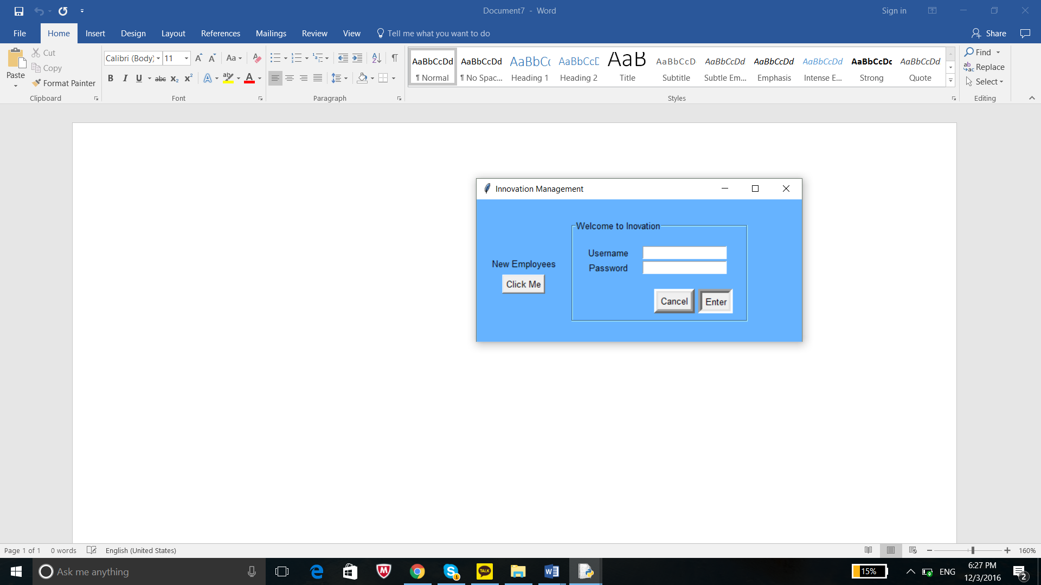

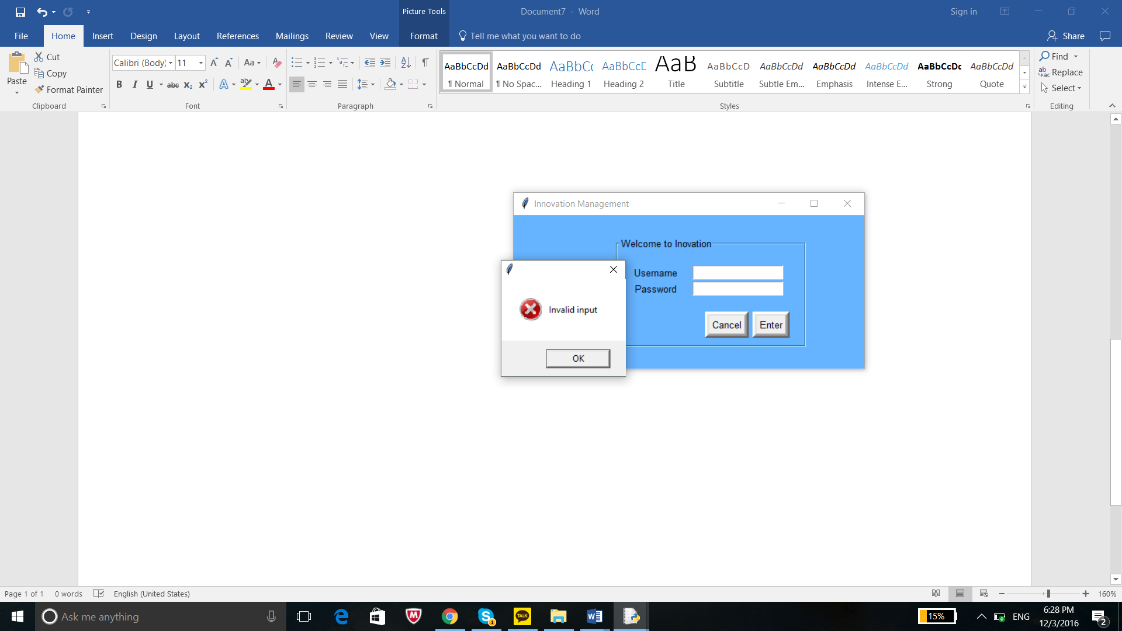

1. Test Case 2 : Press the sign up button.

Expectations: A new layout will appear where the user can put information in.

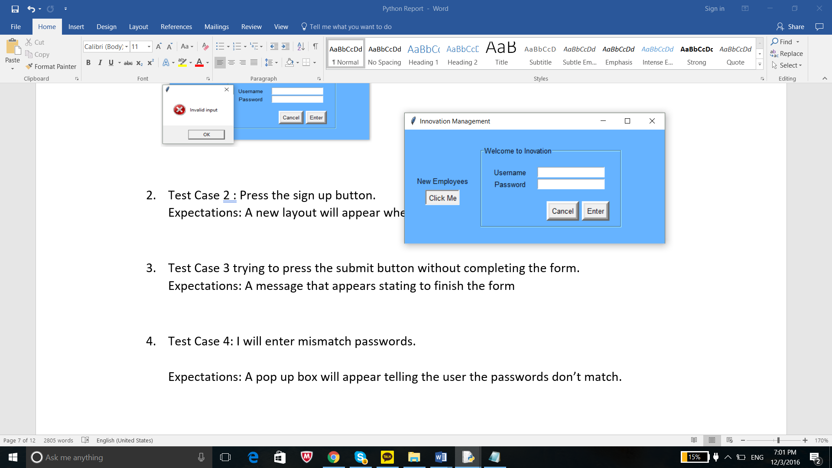

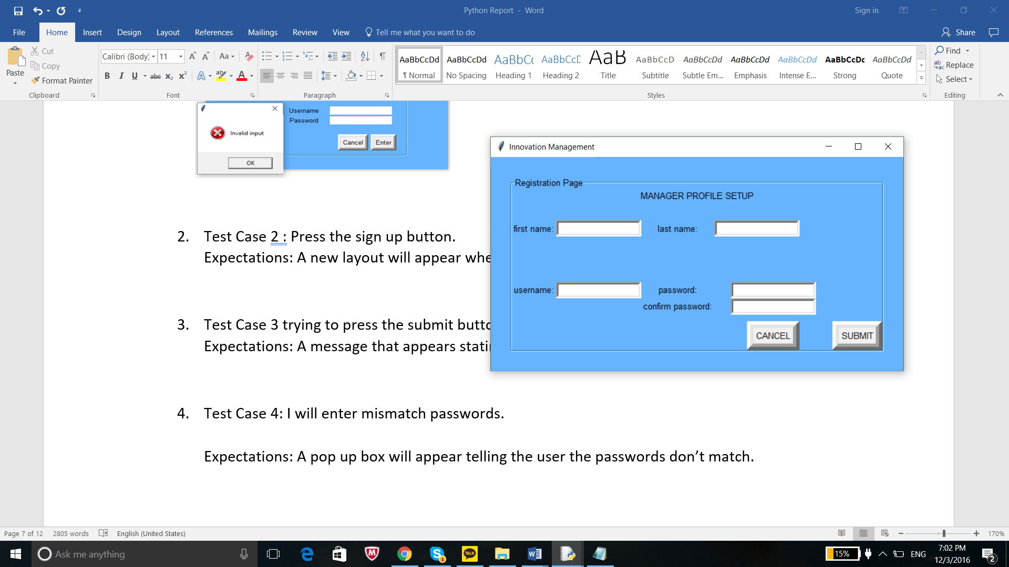

1. Test Case 3 trying to press the submit button without completing the form.

Expectations: A message that appears stating to finish the form

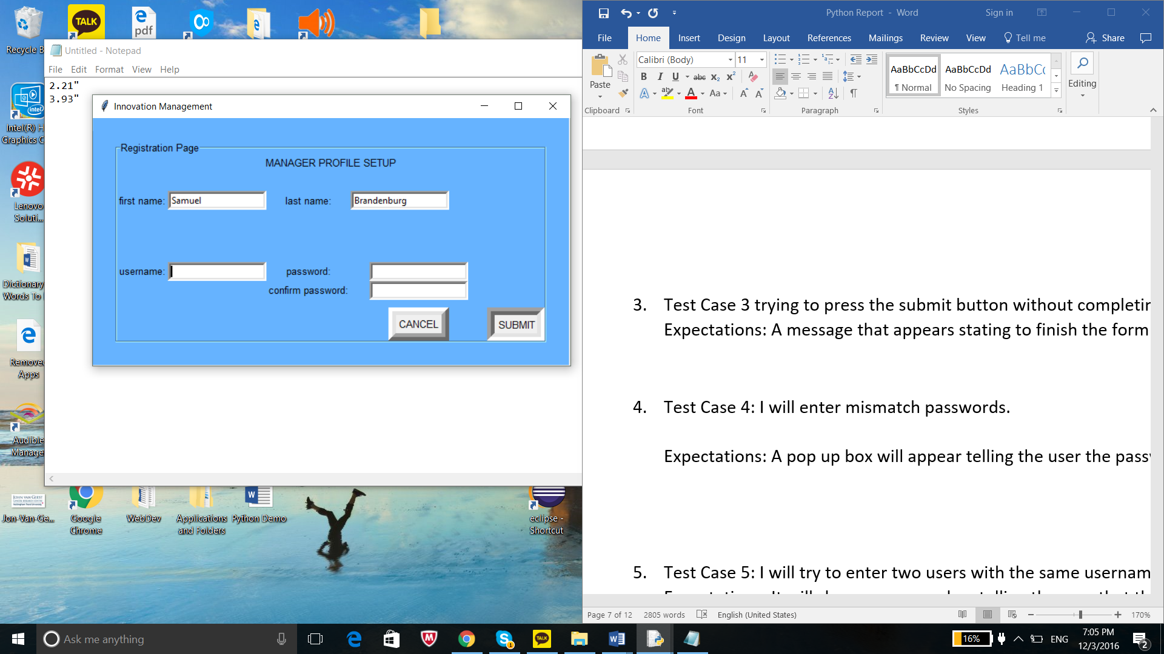

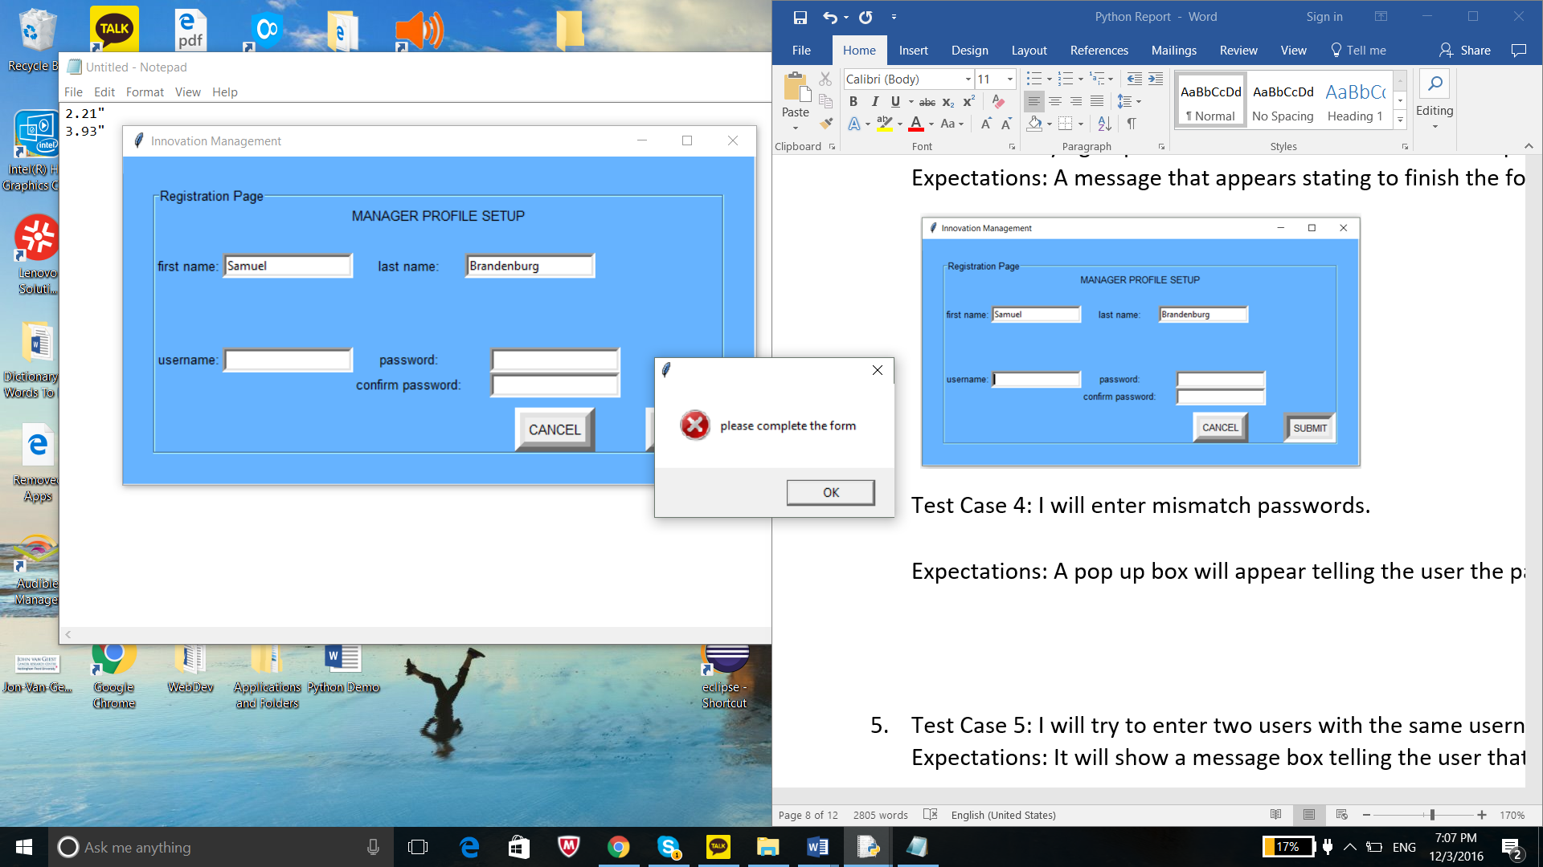

1. Test Case 4: I will enter mismatch passwords.

Expectations: A pop up box will appear telling the user the passwords don’t match.

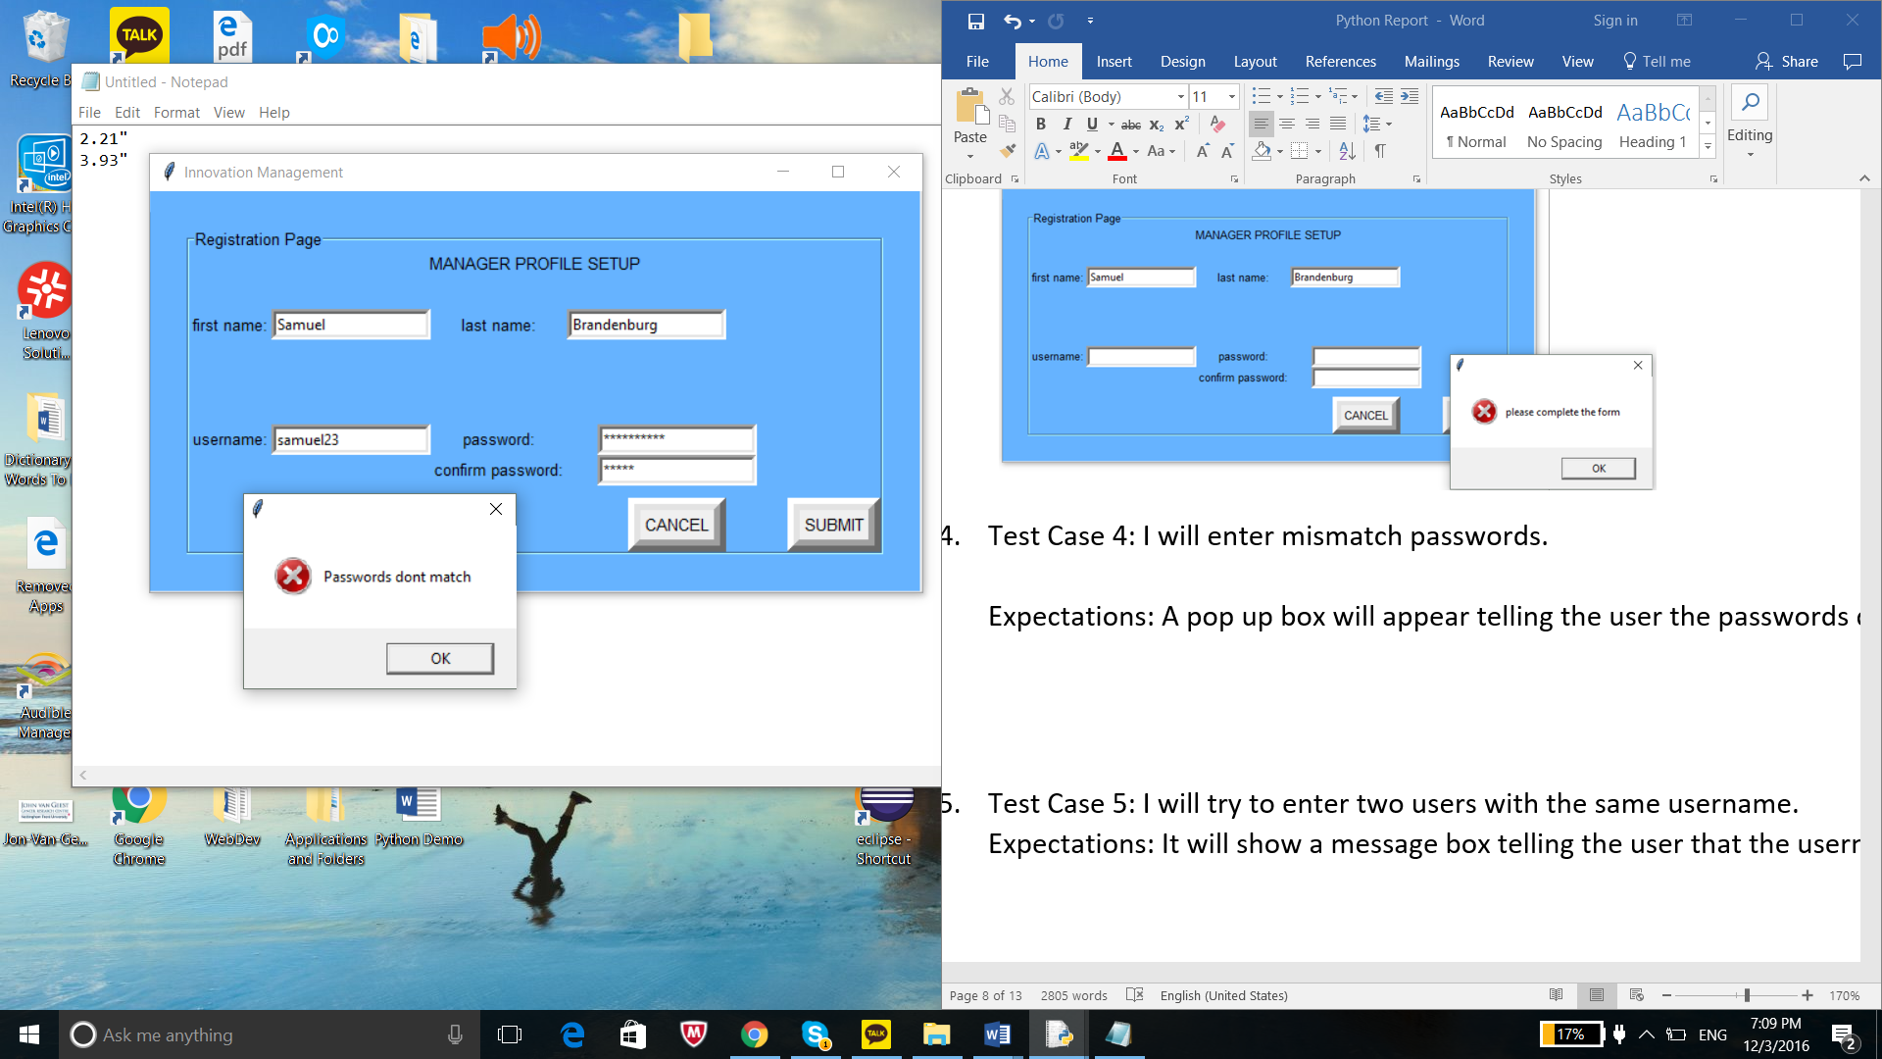

1. Test Case 5: I will try to enter two users with the same username.

Expectations: It will show a message box telling the user that the username already exist.

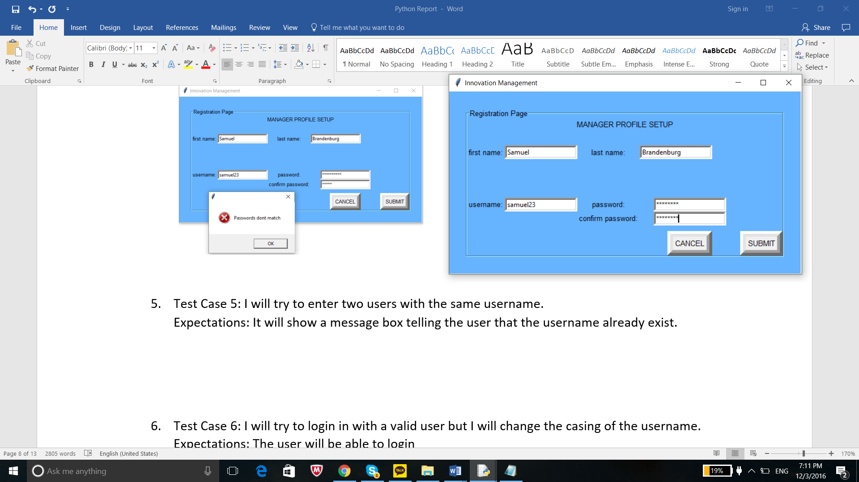

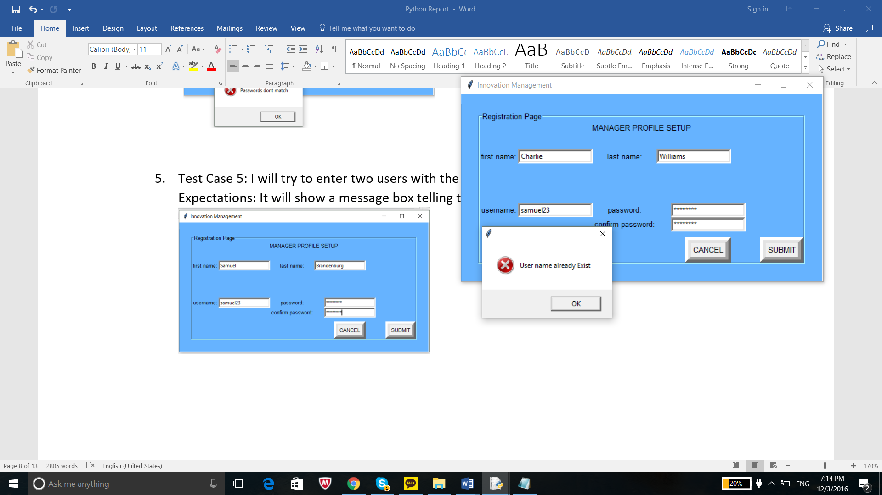

1. Test Case 6: I will try to login in with a valid user but I will change the casing of the username.

Expectations: The user will be able to login

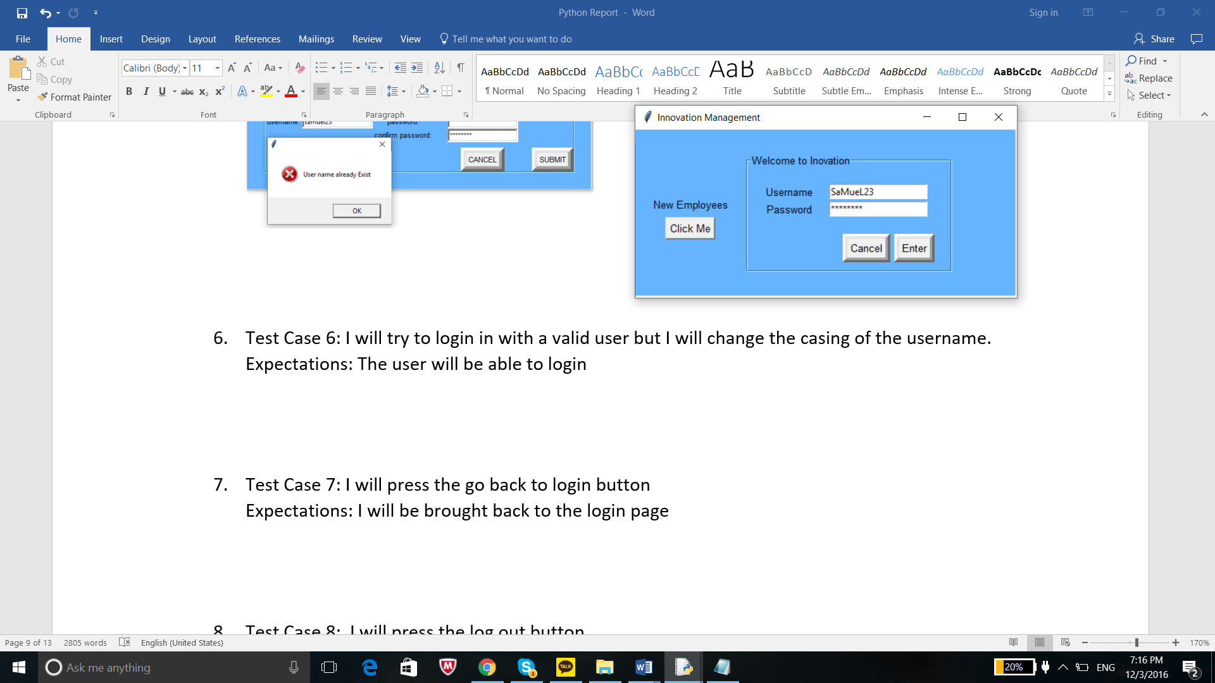

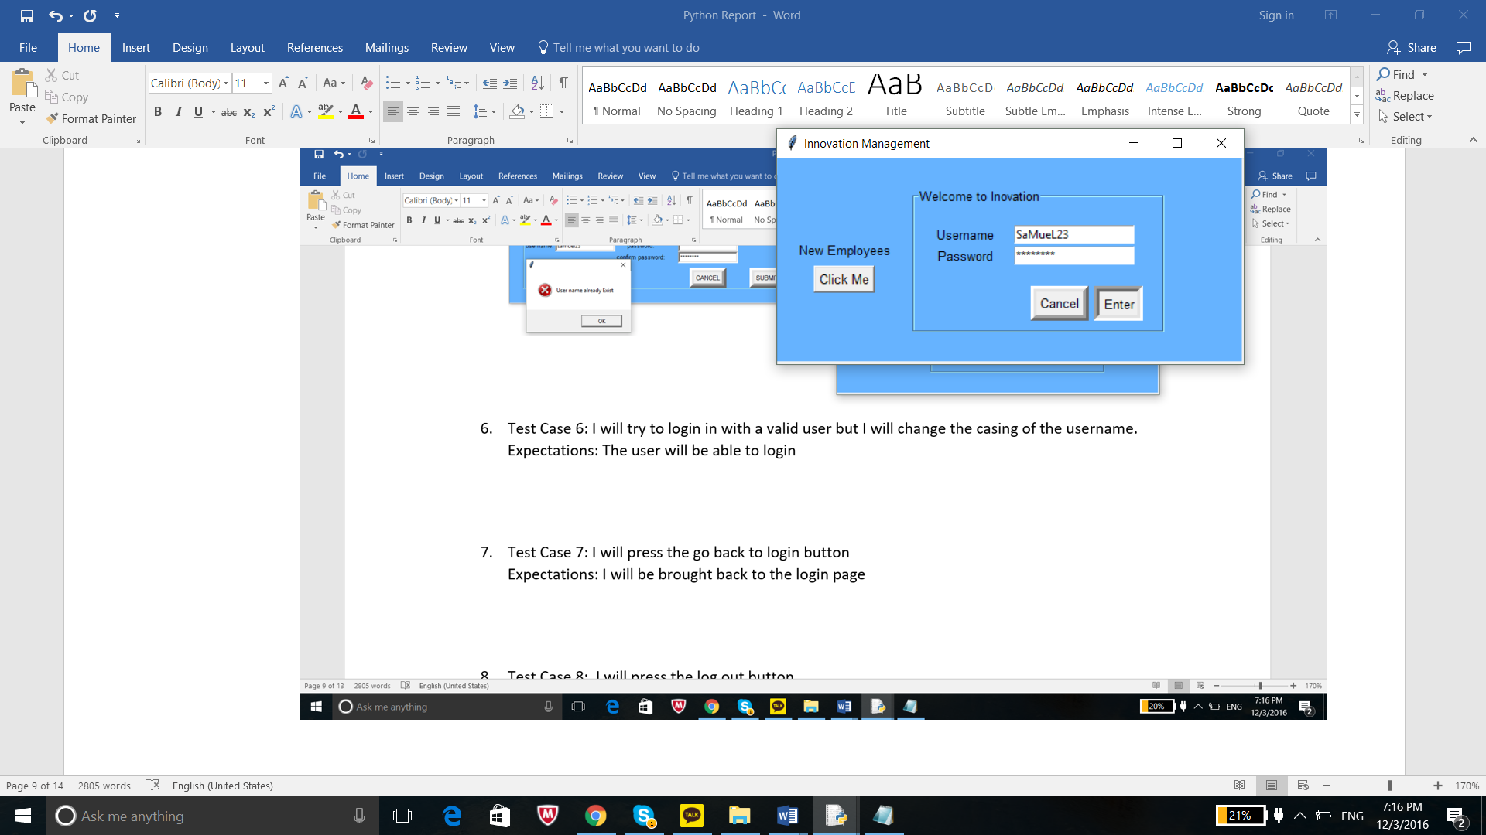

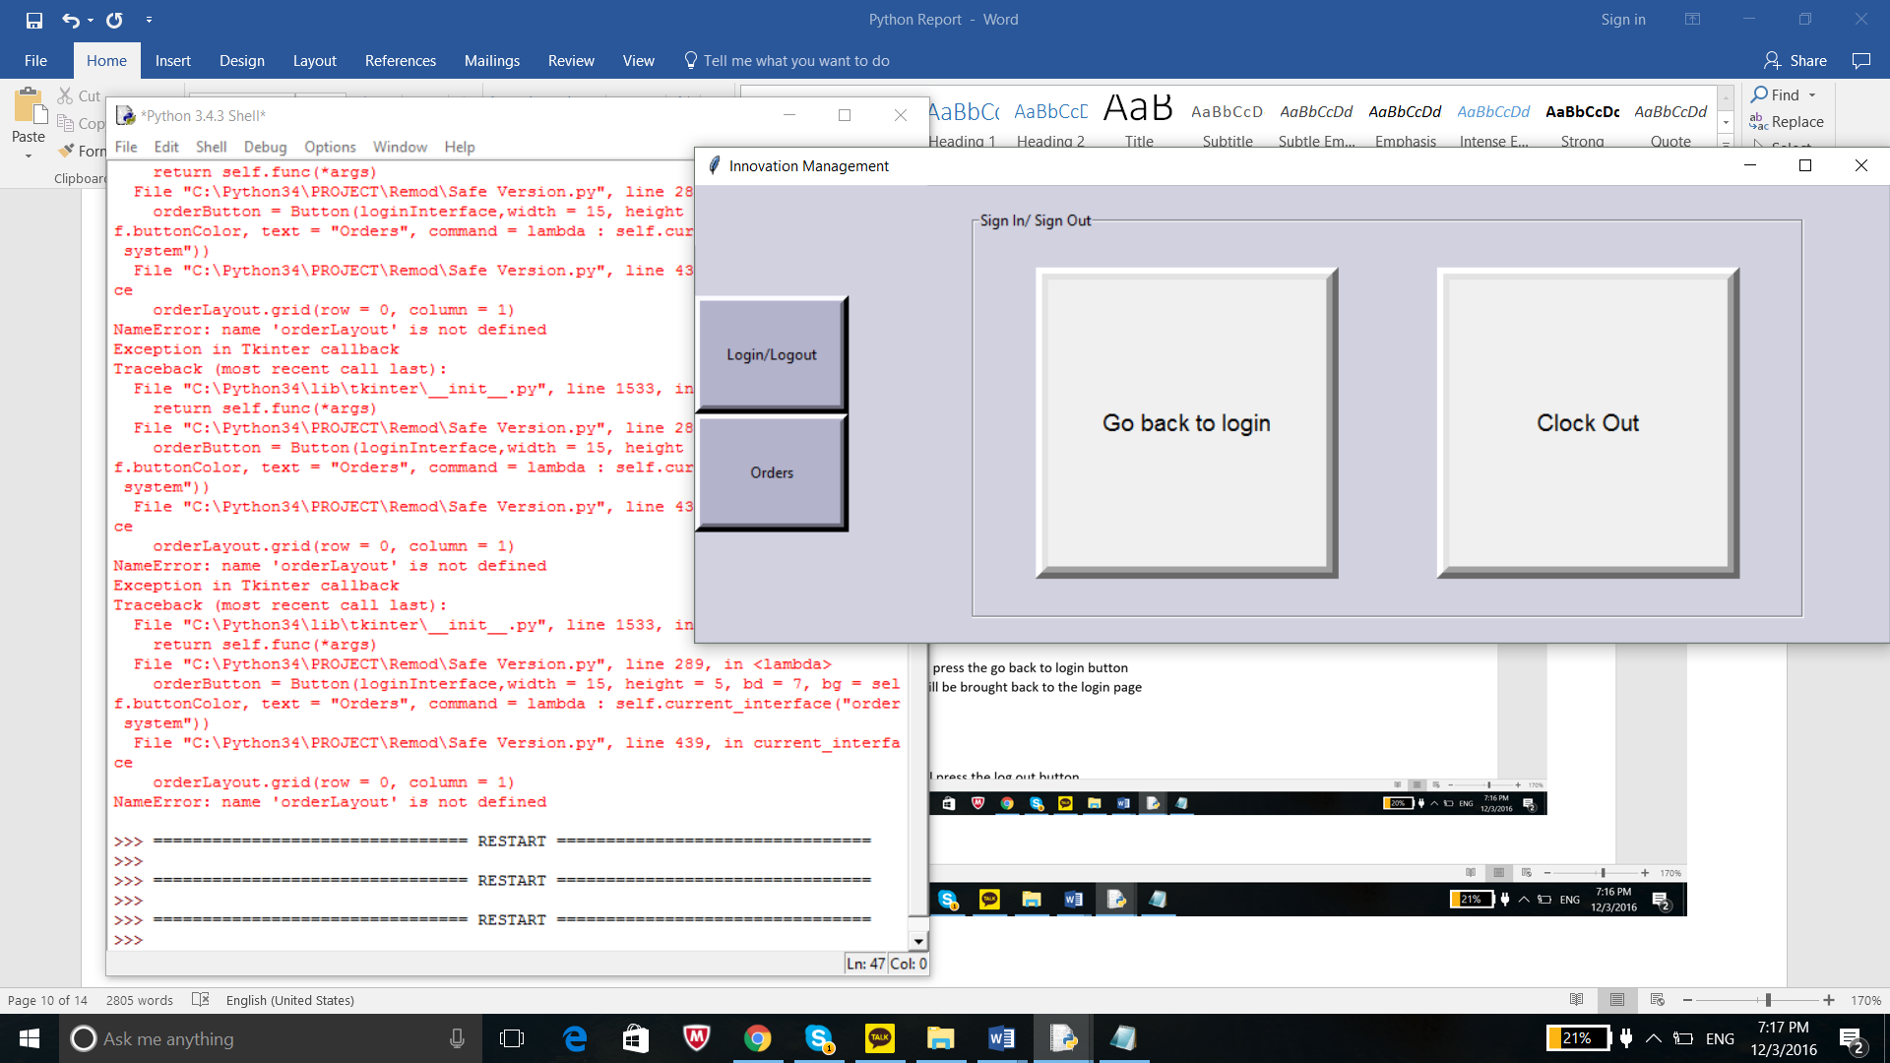

1. Test Case 7: I will press the go back to login button

Expectations: I will be brought back to the login page

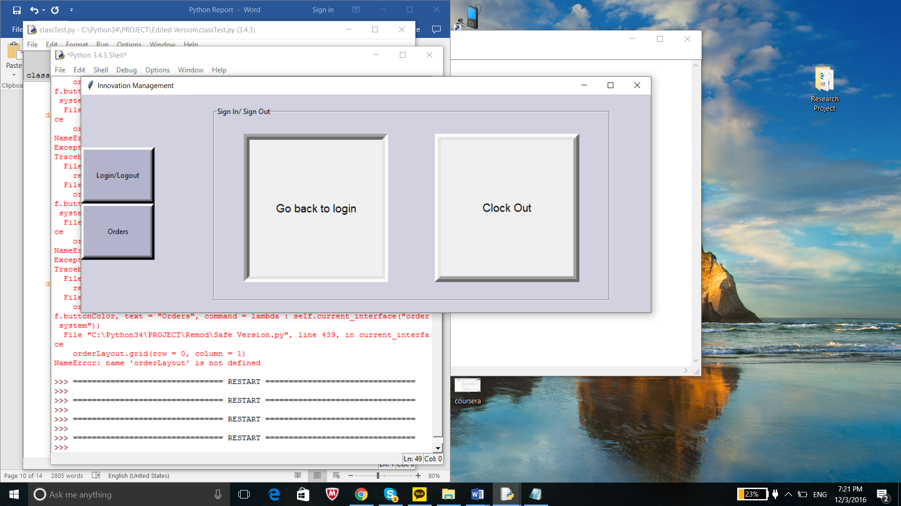

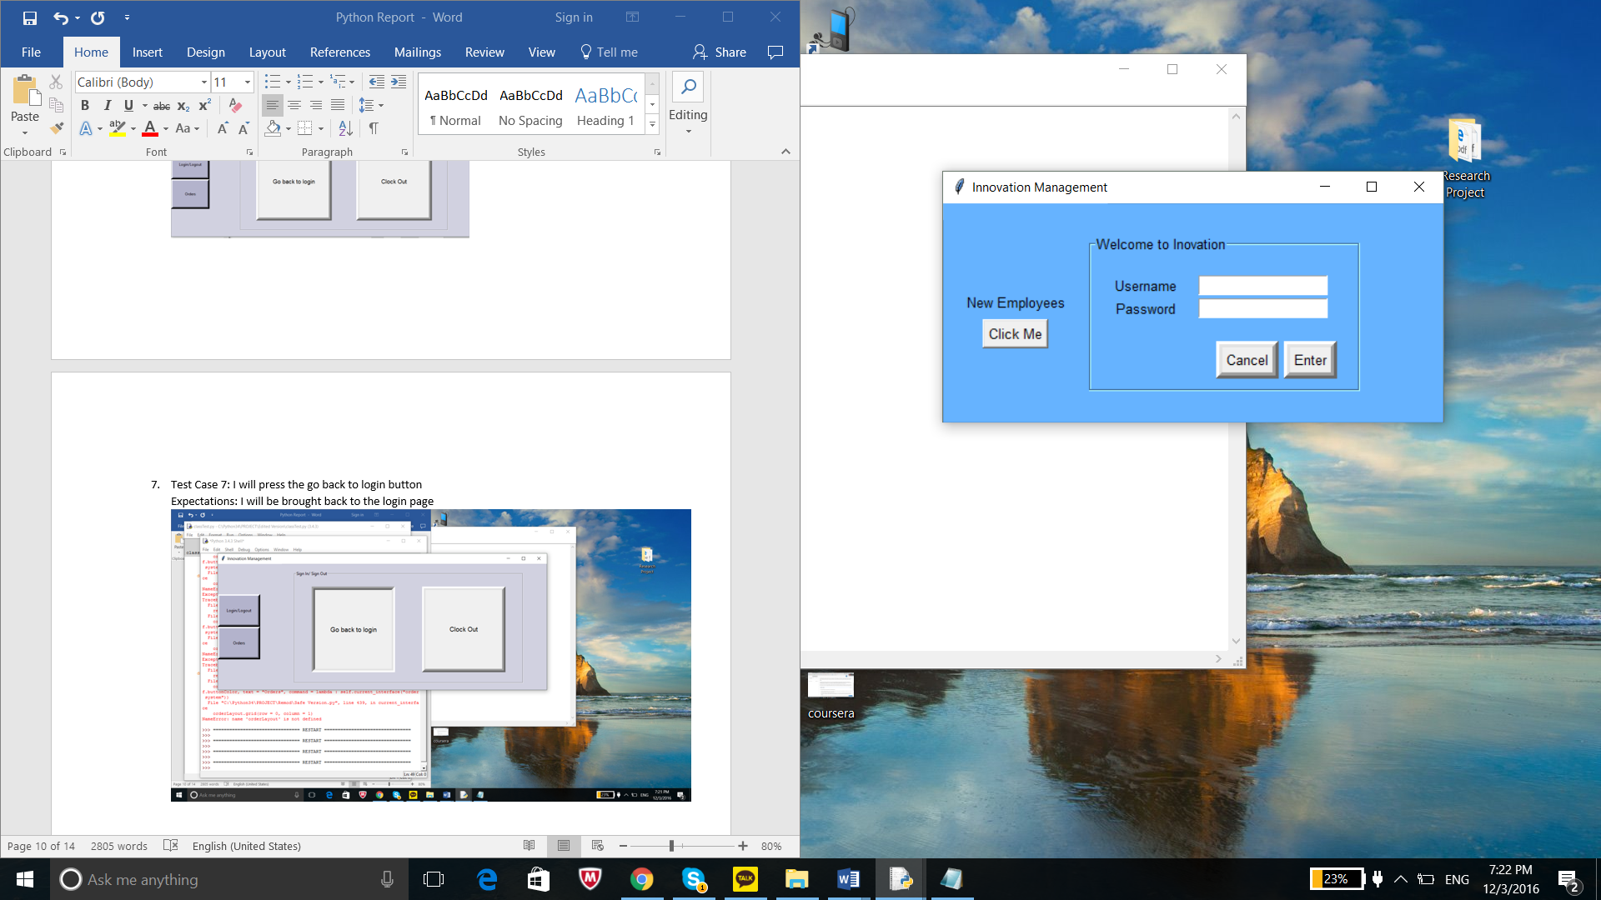

1. Test Case 8: I will press the log out button.

Expectations: The program will be closed

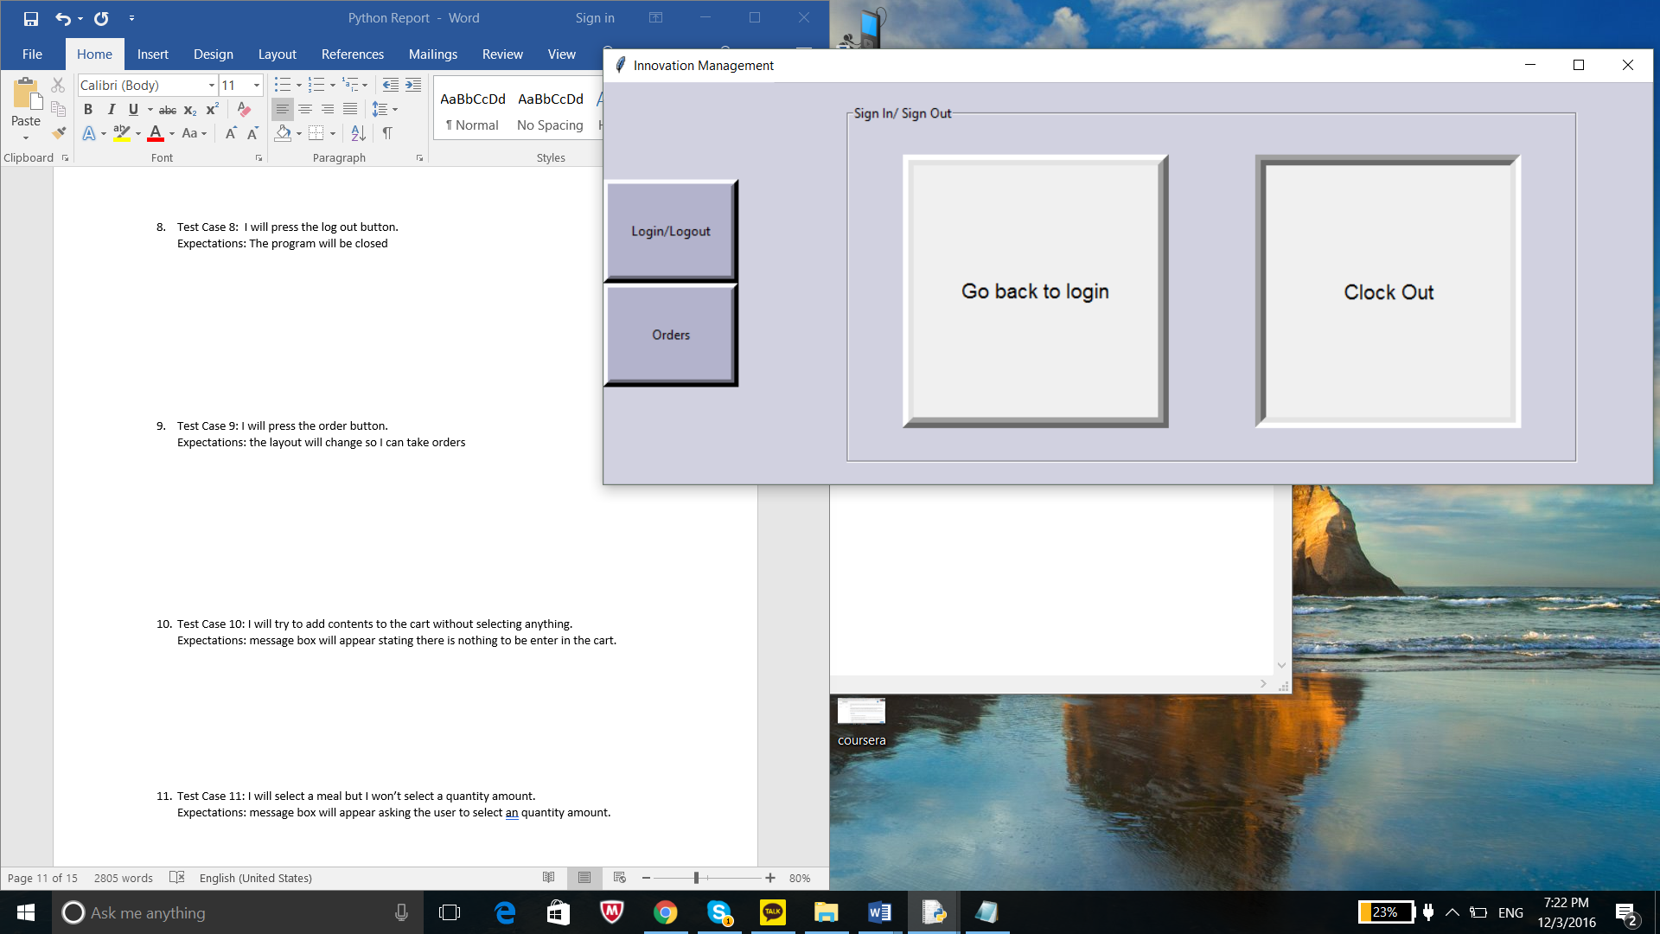

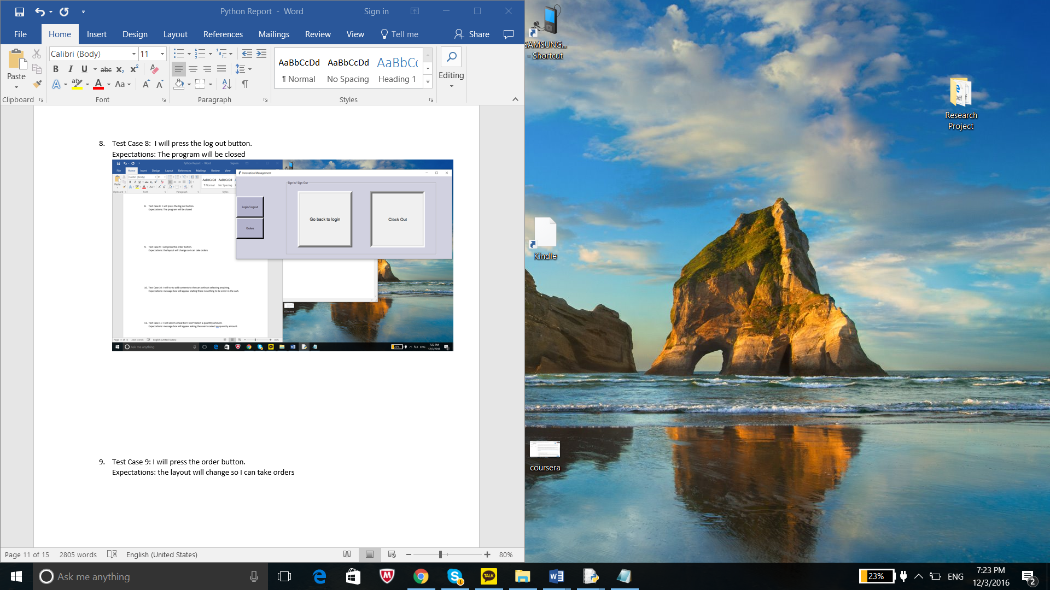

1. Test Case 9: I will press the order button.

Expectations: the layout will change so I can take orders

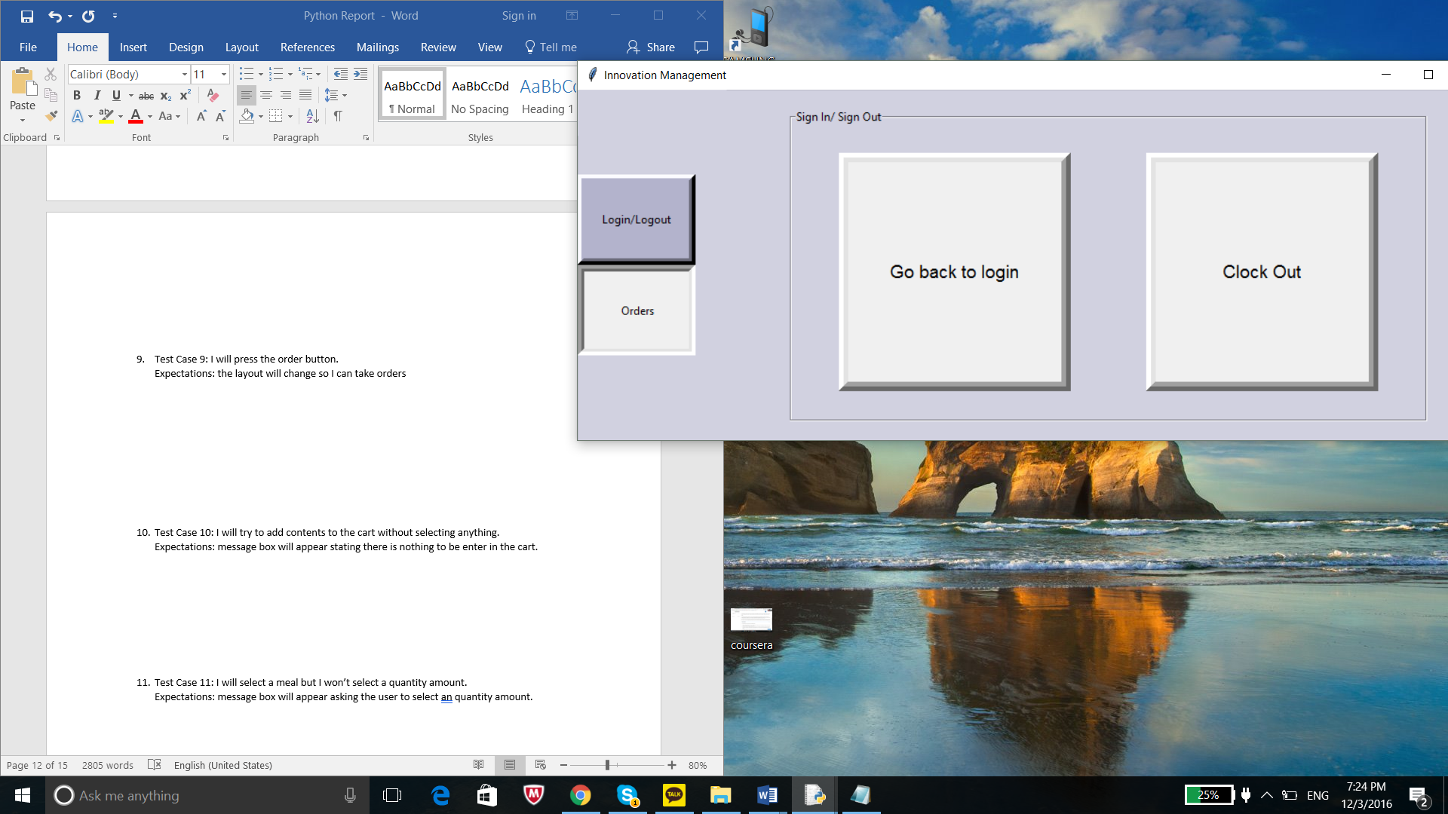

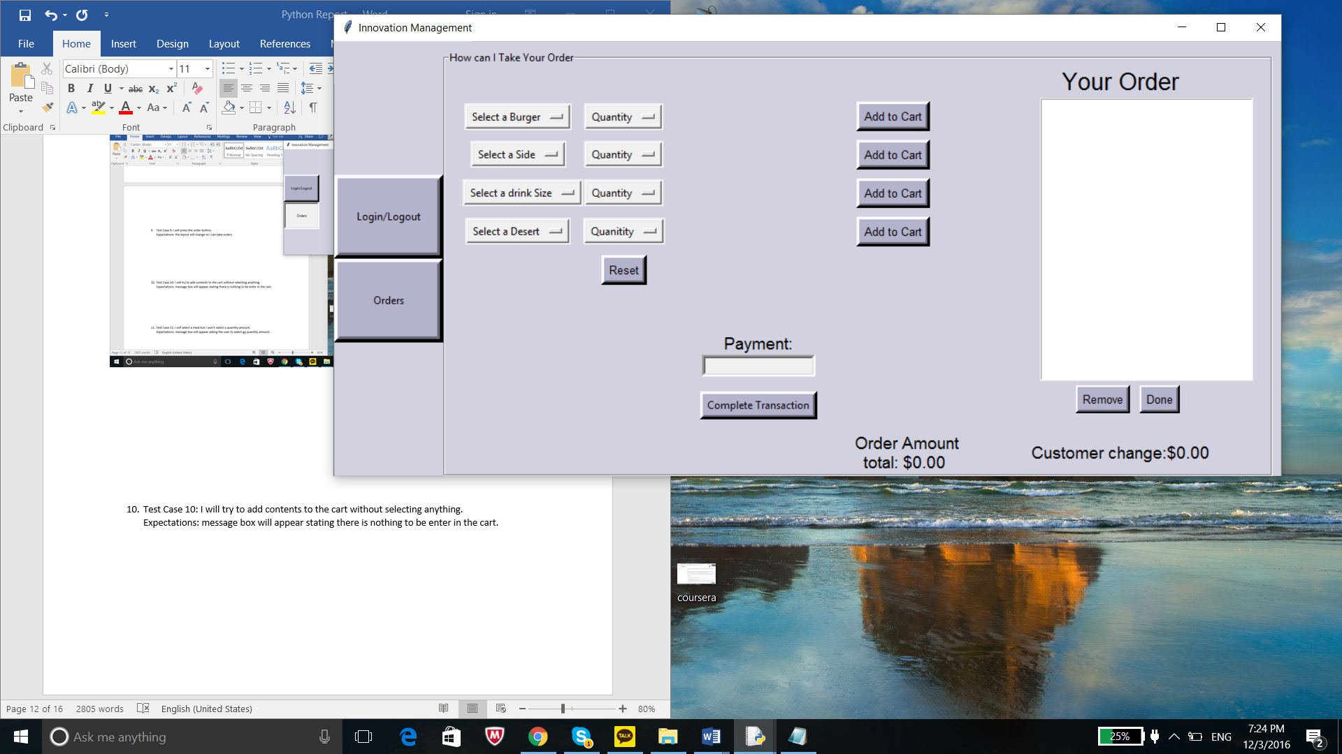

1. Test Case 10: I will try to add contents to the cart without selecting anything.

Expectations: message box will appear stating there is nothing to be enter in the cart.

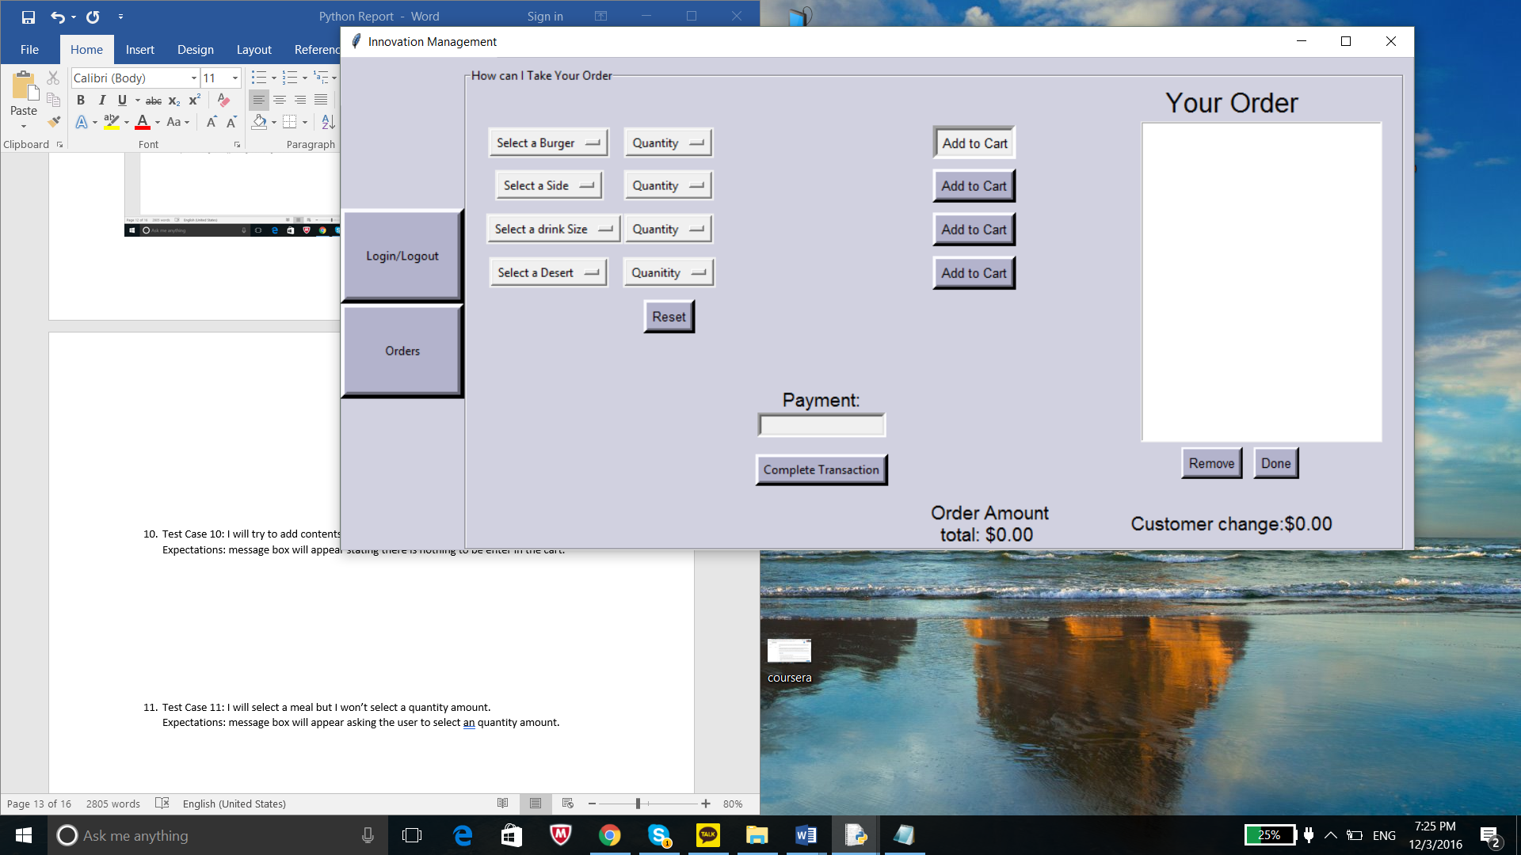

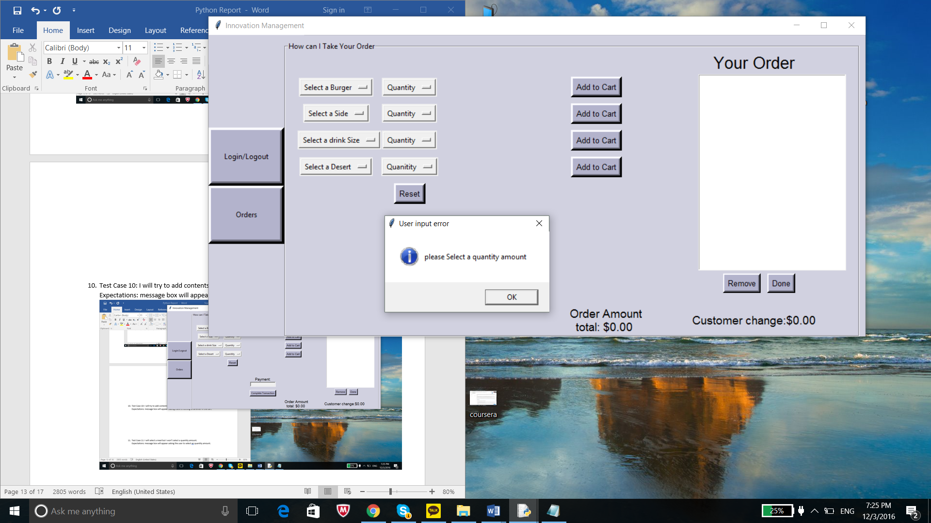

1. Test Case 11: I will select a meal but I won’t select a quantity amount.

Expectations: message box will appear asking the user to select an quantity amount.

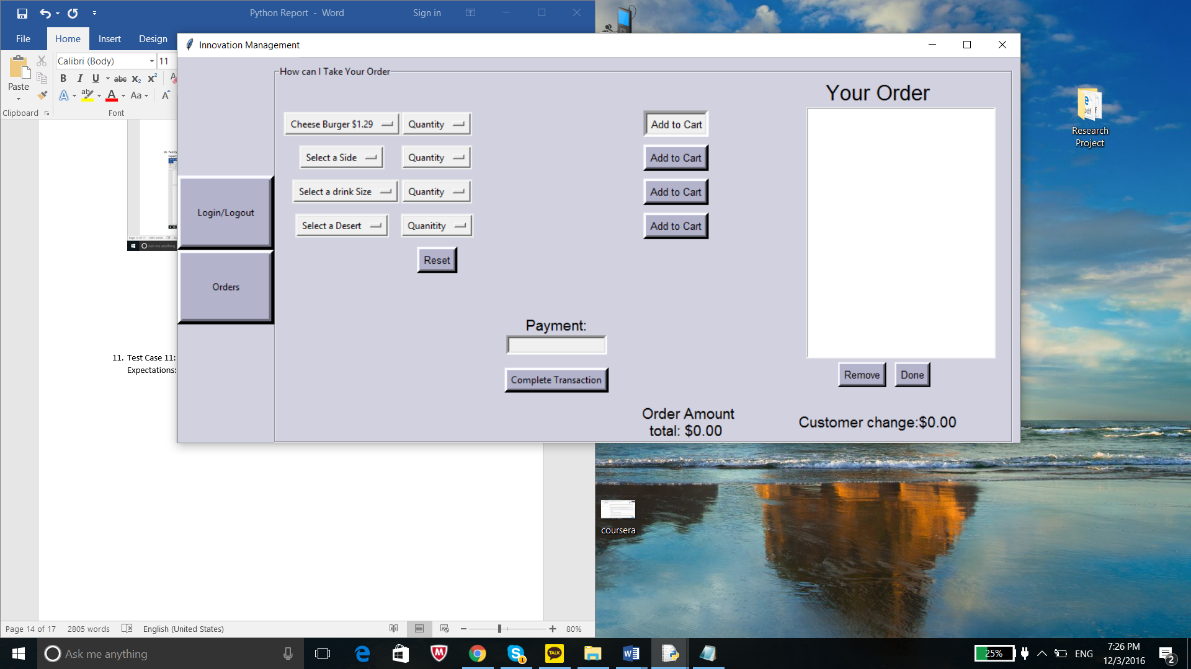

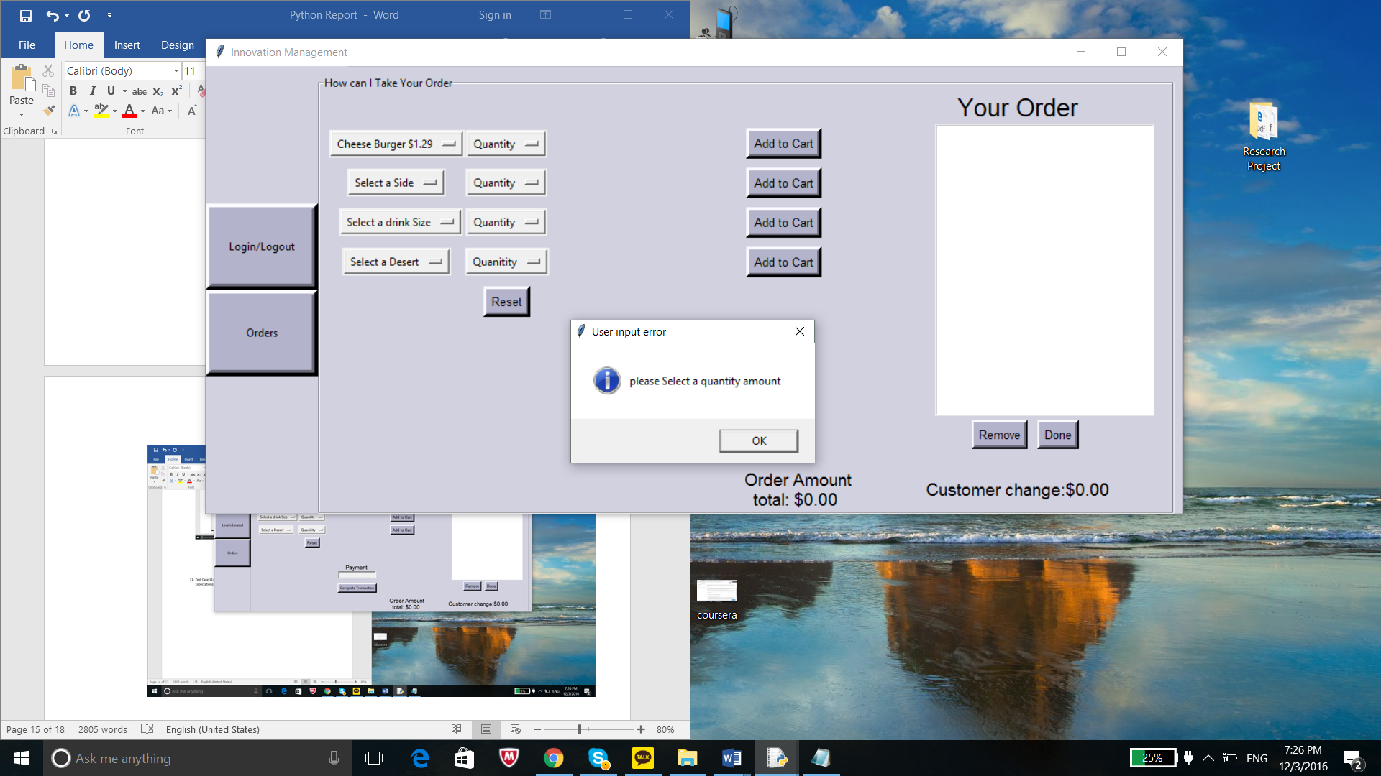

1. Test Case 12: I will select a meal and a quantity amount.

Expectations: I expect for it to be entered in the cart and the order amount will change.

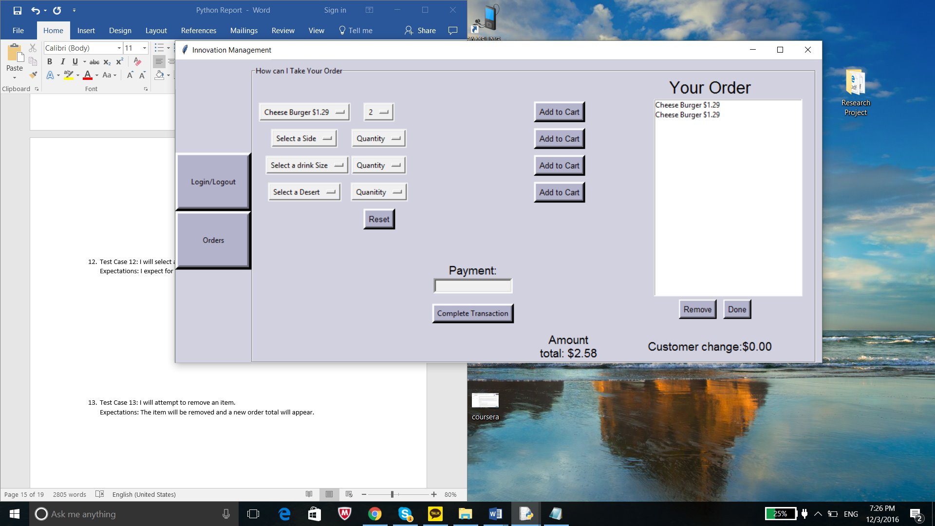

1. Test Case 13: I will attempt to remove an item.

Expectations: The item will be removed and a new order total will appear.

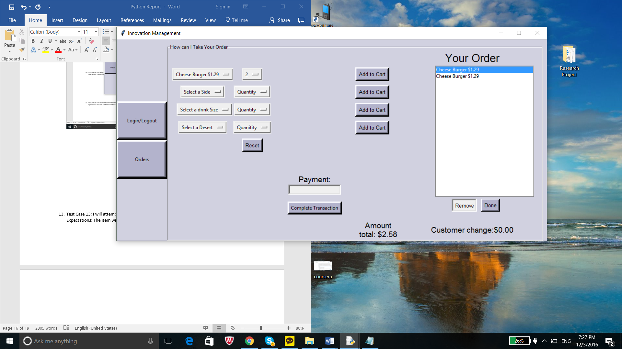

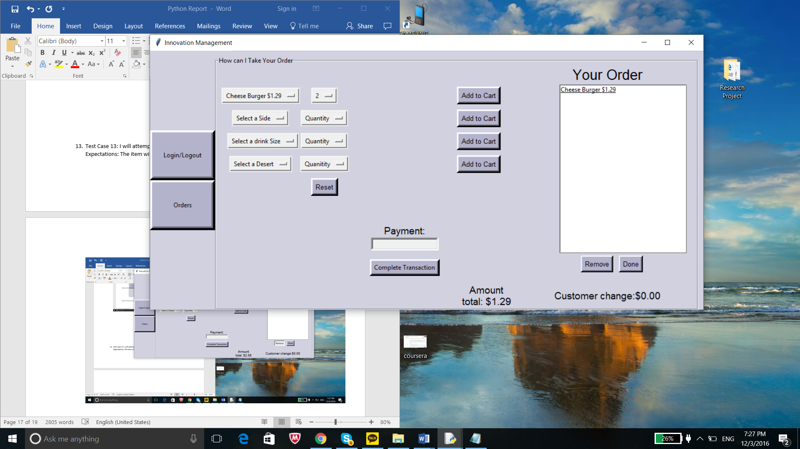

1. Test Case 14: I will try to make a payment when the cart is empty.

Expectations: message box will appear stating the cart is empty and it won’t take the payment.

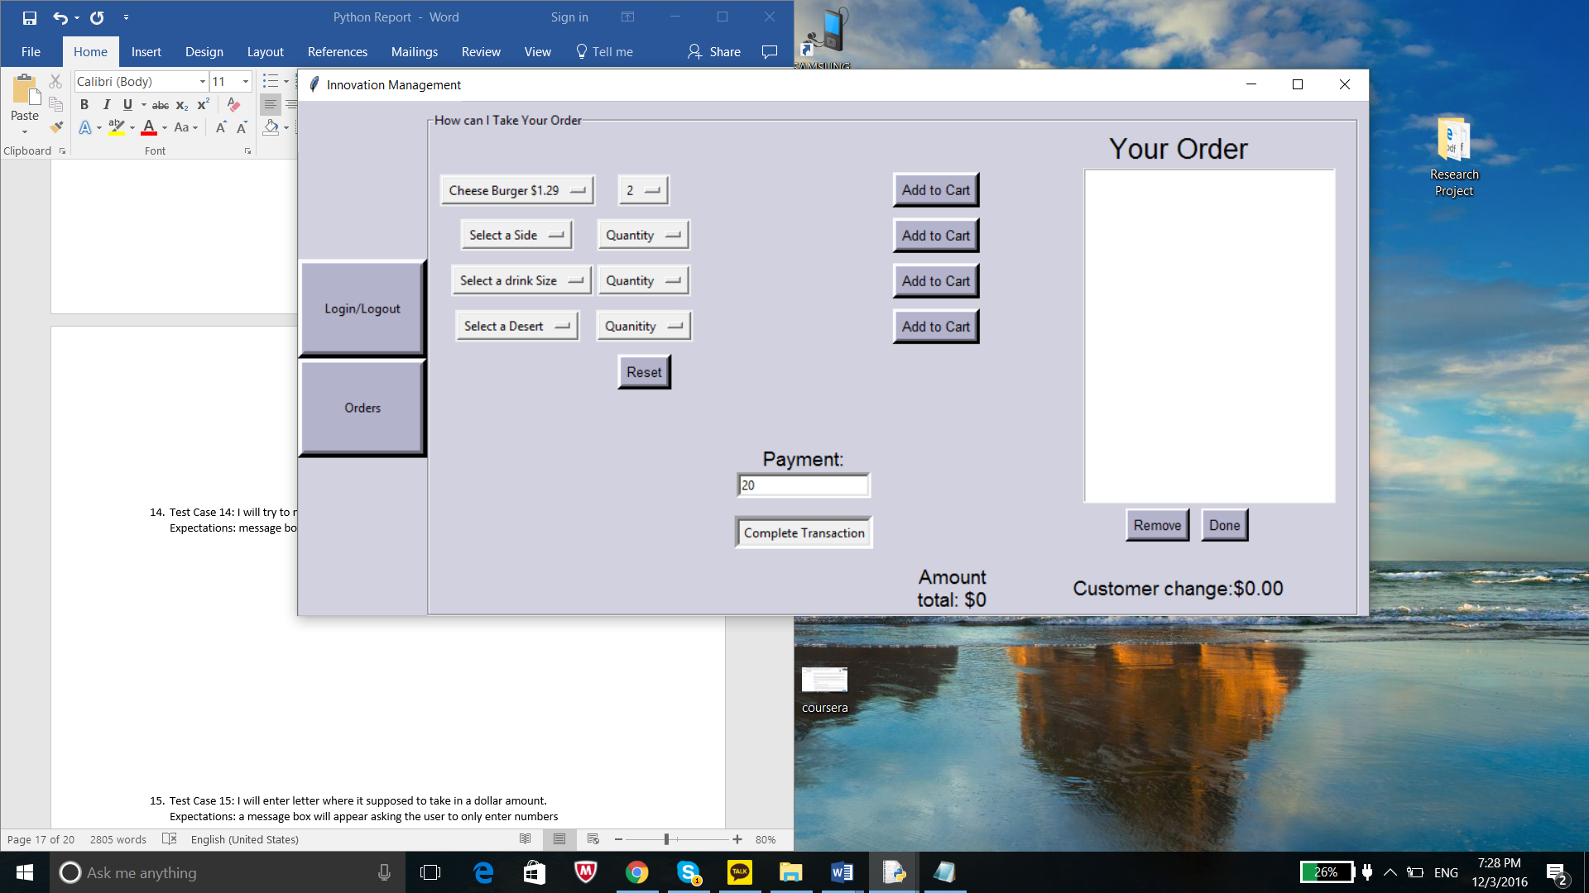

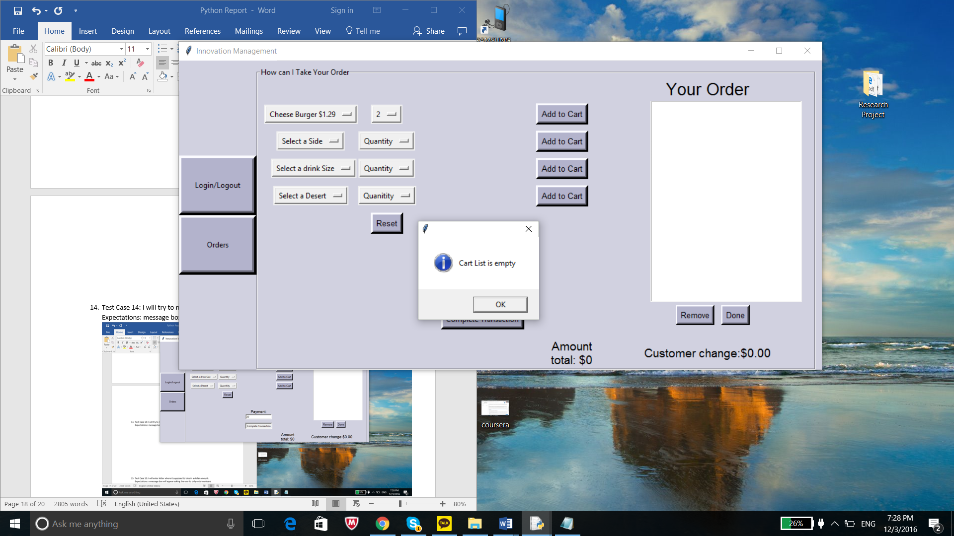

1. Test Case 15: I will enter a letter where it supposed to take in a dollar amount.

Expectations: a message box will appear asking the user to only enter numbers

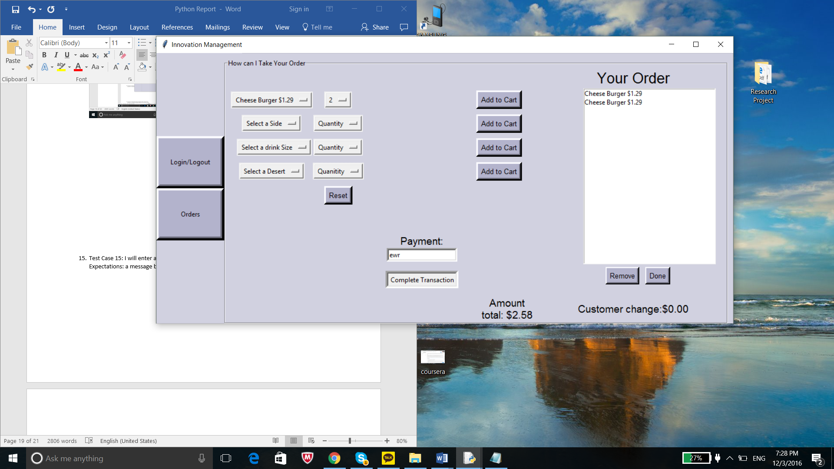

b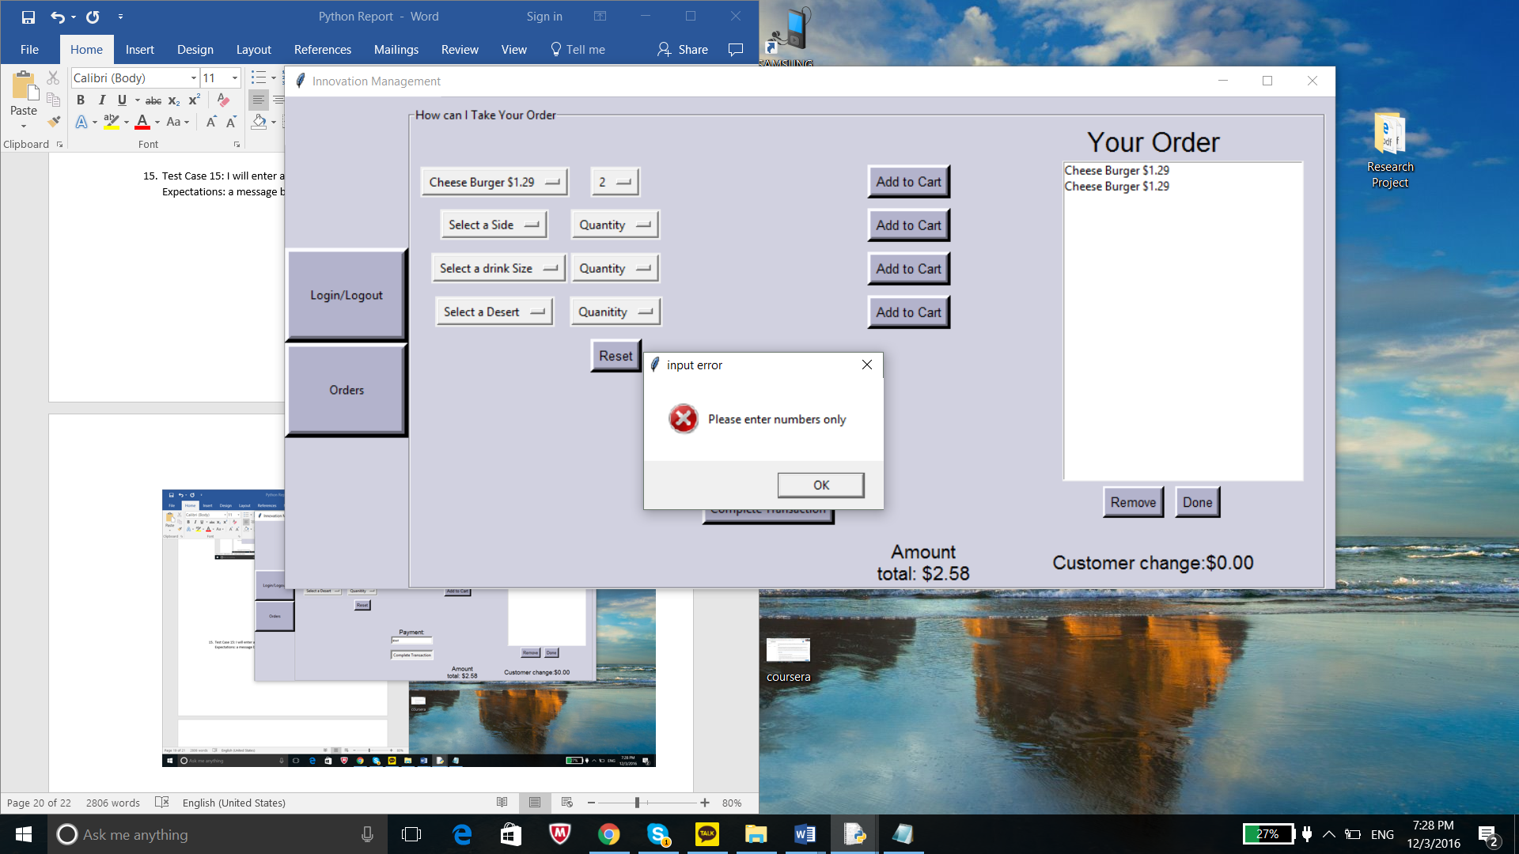

1. Test Case 16: I will pay 20 dollars to a meal that is less than 10 dollars.

Expectations: The label “customer change” will change reflecting how much cash to return to the customer.

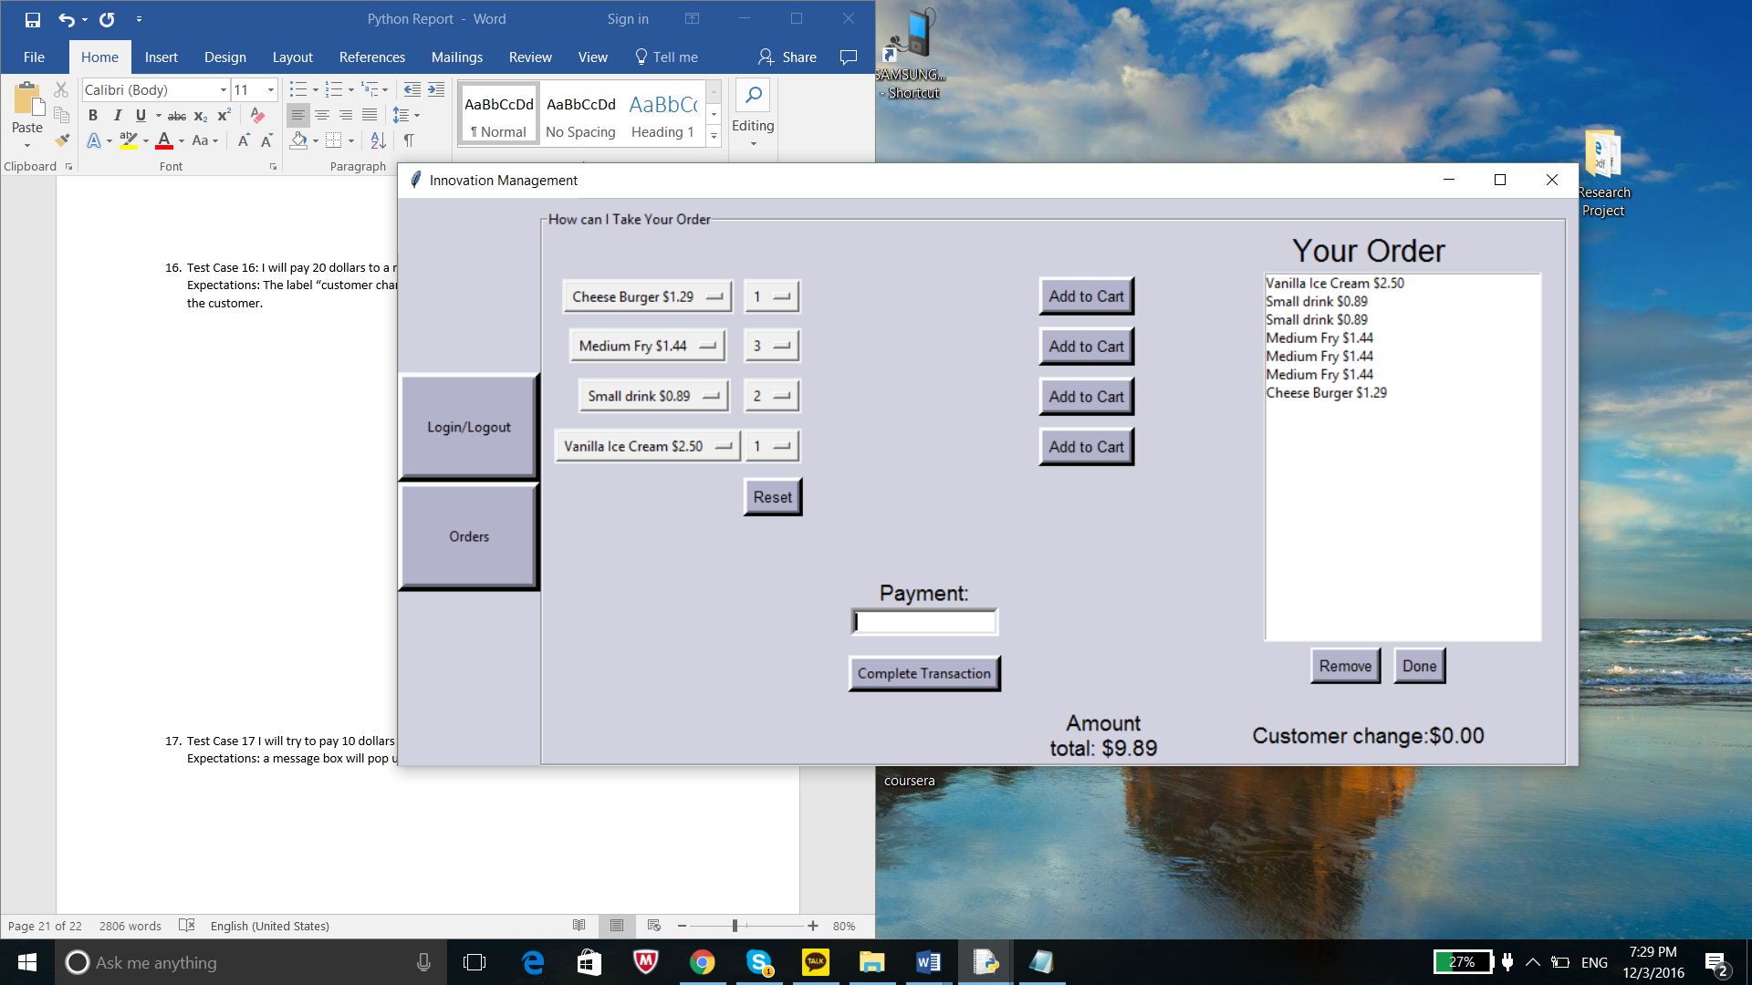

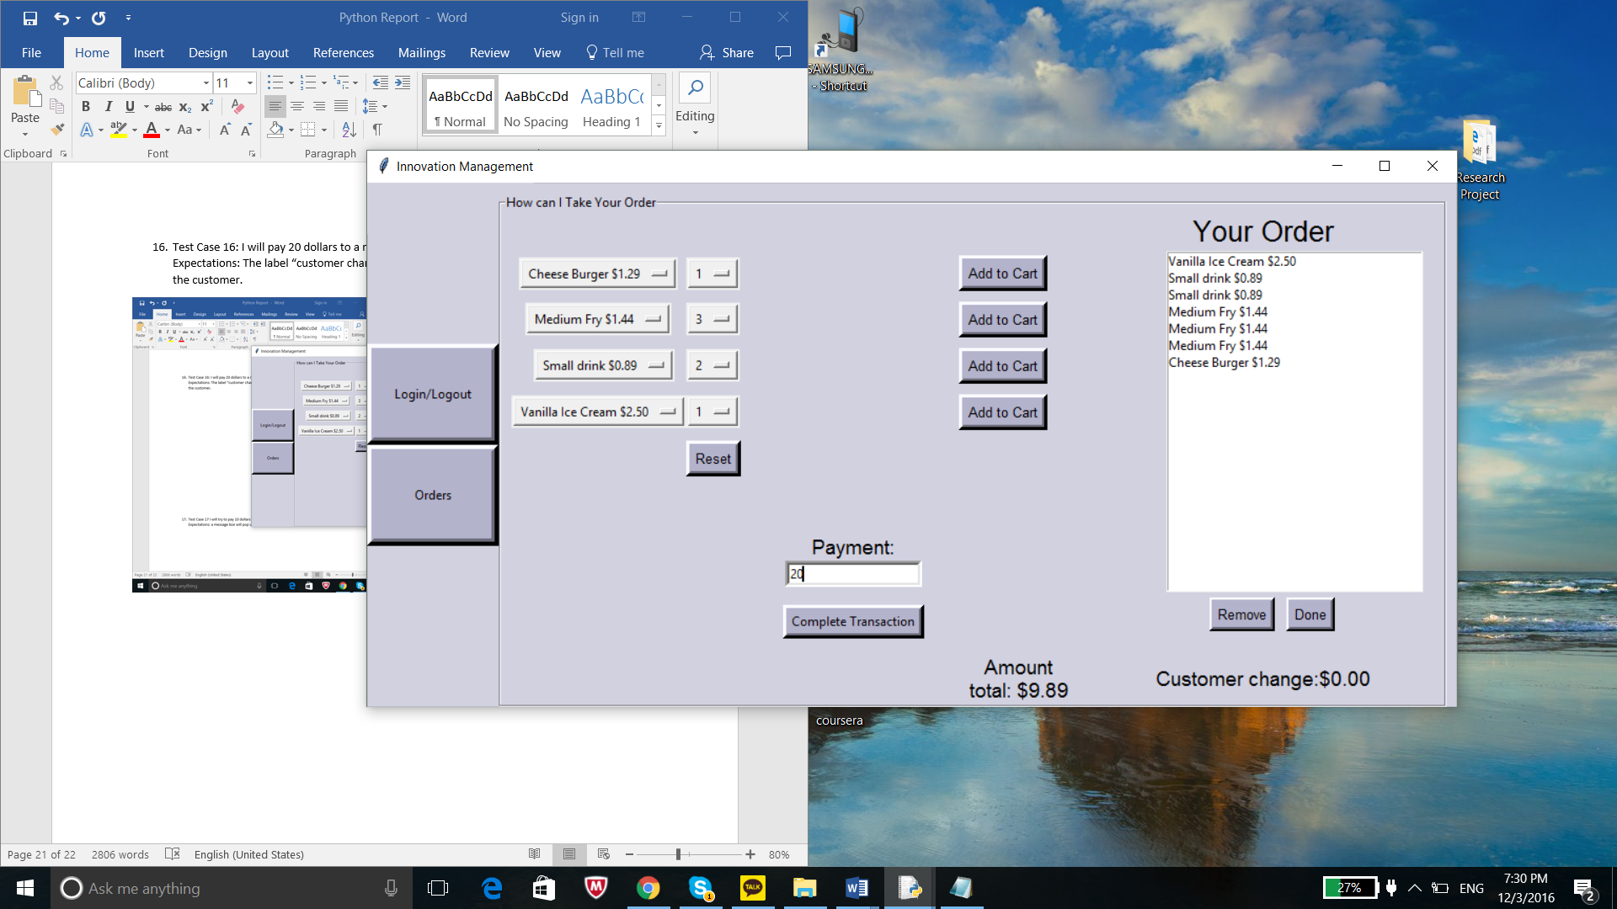

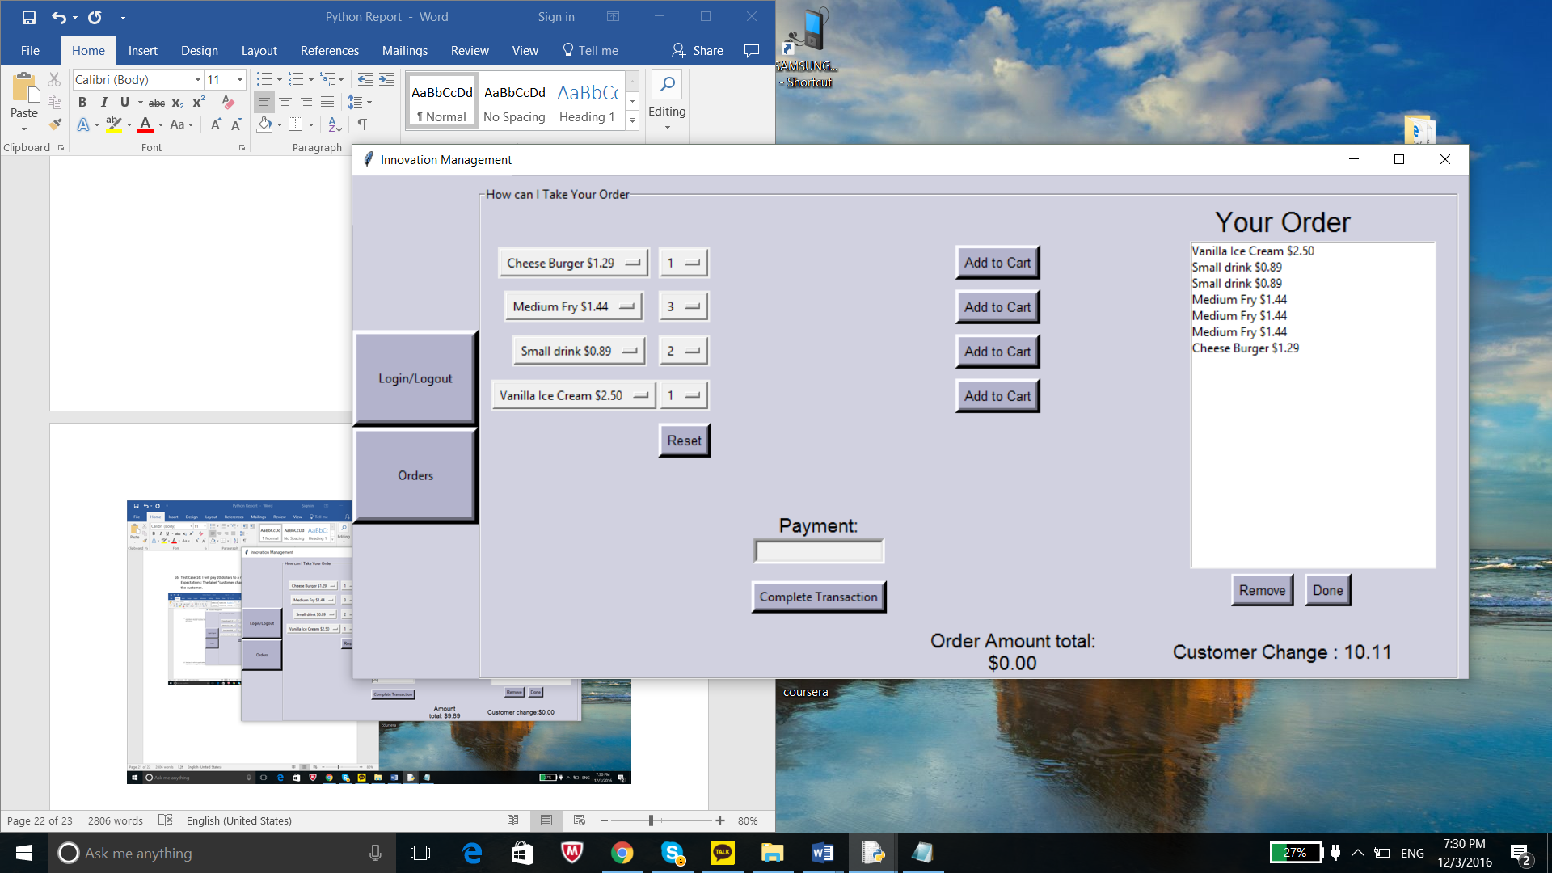

1. Test Case 17 I will try to pay 10 dollars for a meal that cost 20 dollars.

Expectations: a message box will pop up stating it is not enough

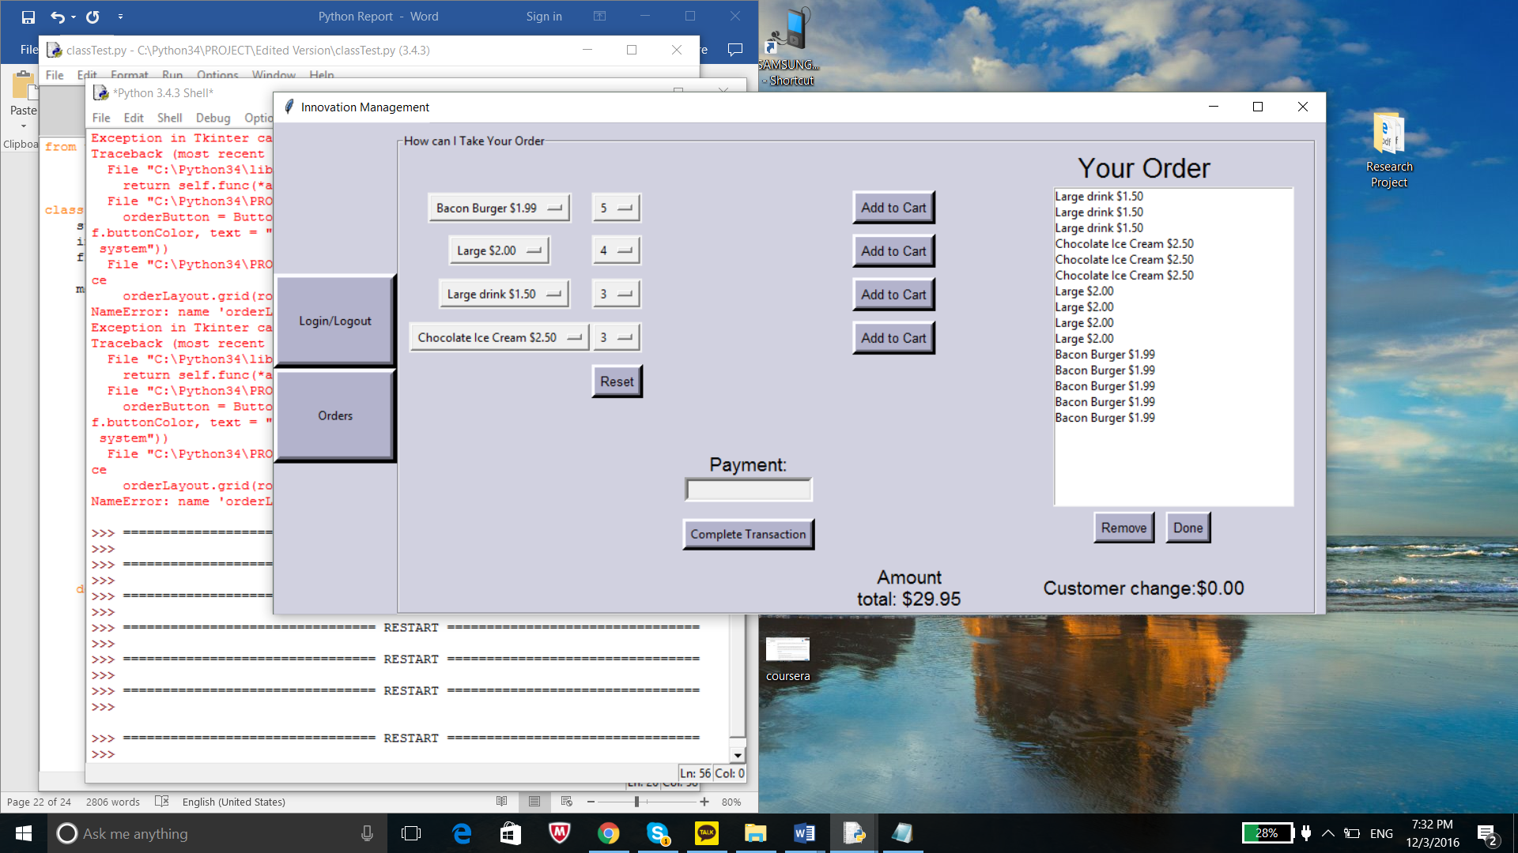

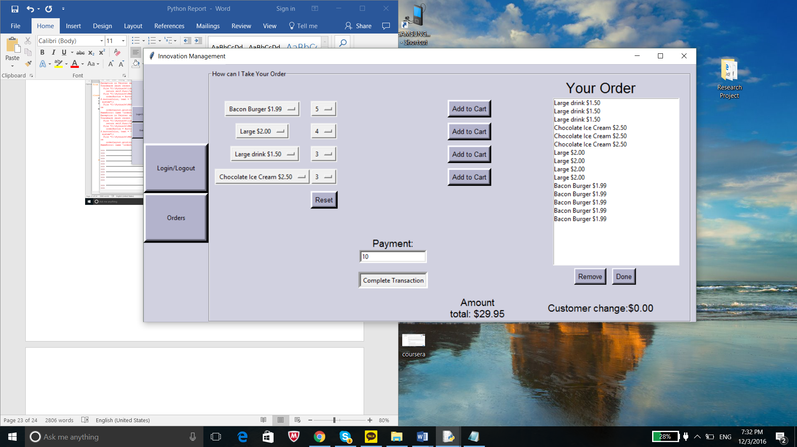

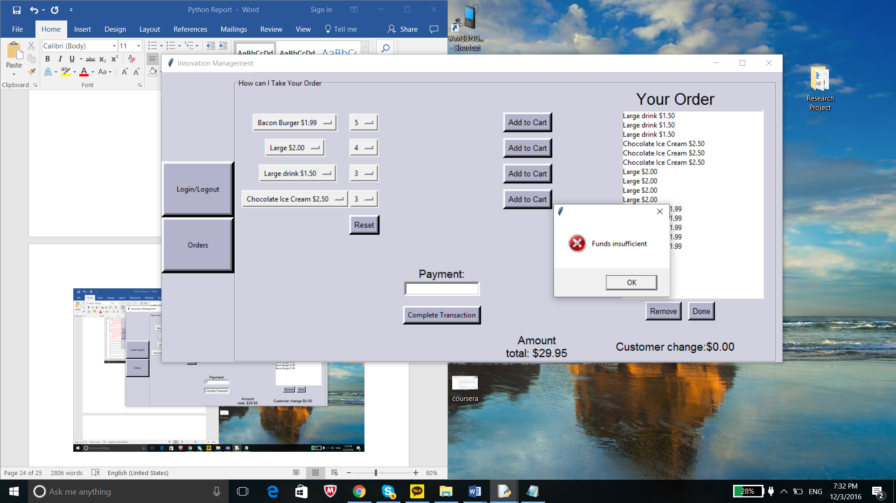

1. Test Case 18: I will try to make two orders without first pressing reset.

Expectations: a message box will pop up asking for the user to press the reset button

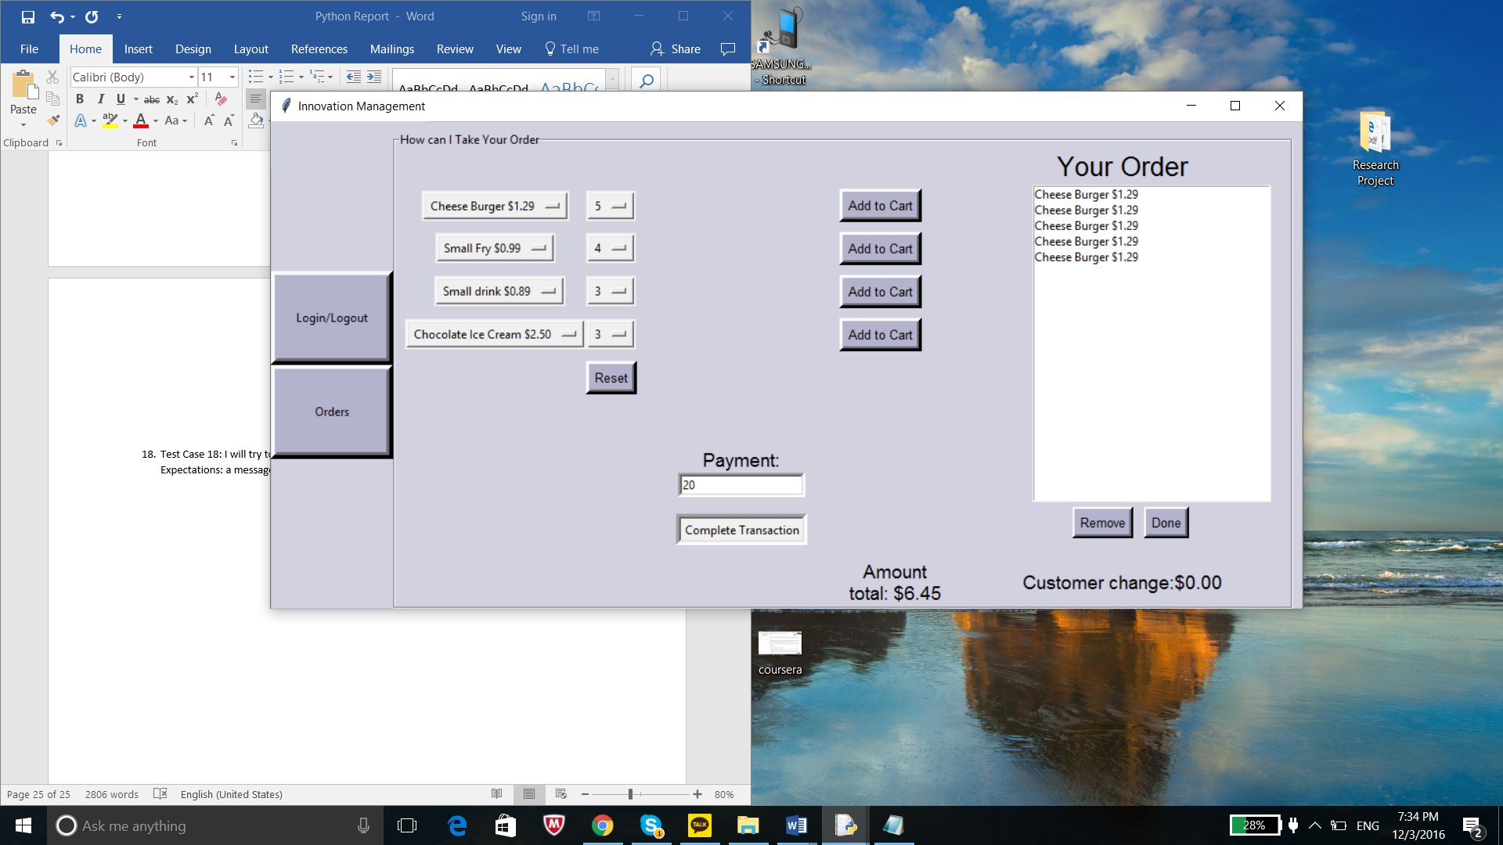

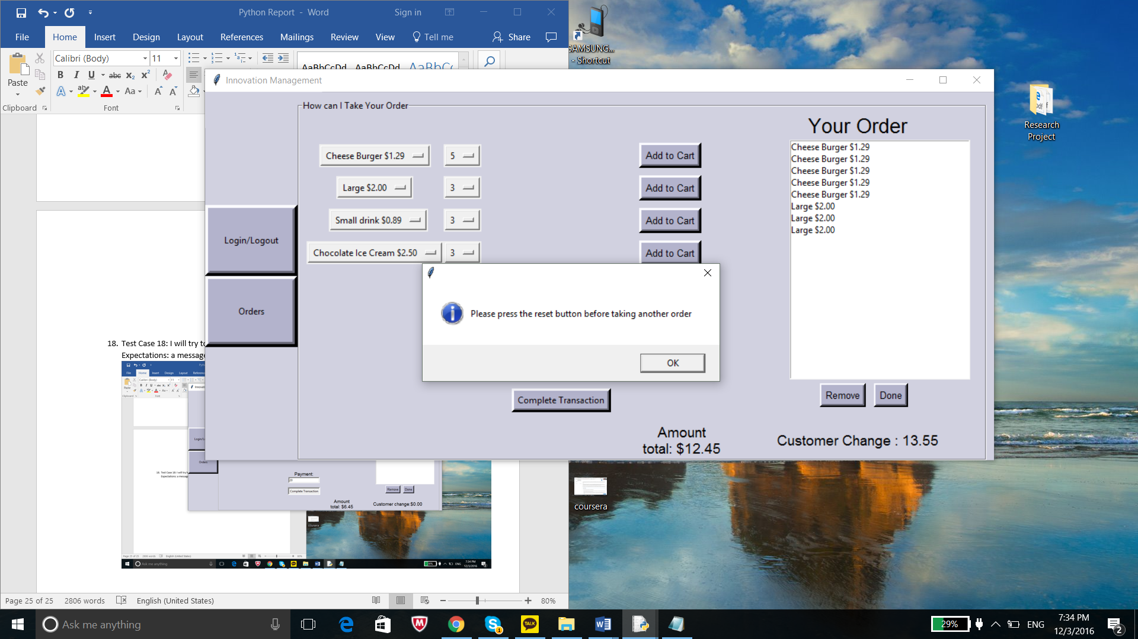

Critique

In the beginning of creating my program I faced many problems; such as, finding an efficient way to structure my code, learning Tkinter, and how to switch between different layouts. I was able to find solutions for many of the problems I encountered; however, I know that I could have done better in structuring my program. I wanted to focus on making it object-oriented by using a class and methods for different functions in the program. The main issue I encountered was getting methods outside of each other access to local variables of one methods. In my first two graphical layouts, one layout took up the whole frame. Therefore, it was easy for me to pass the variable that contained all the widgets for that specific layout as a parameter to an outside method. Once passed to the outside method, I used a function of that widget that stops displaying the widget from displaying. The next step was to call the other method that would bring up a different layout. However, once the user enters a correct username the display disappears through the same process and the main application appears. When I created the main display, I created three separate layouts. Earlier the frame only used one layout for the frame, but once in the main application the frame is divide in to two’s. On the far-left side I used a method that creates two buttons. These buttons are supposed to allow the user to switch between the main screen and the digital cash register which displays several drop down menus. I faced a lot of issues trying to find a way to get the far-right display to change with its opposite. The display on the left stays never disappears unless a user decides to go back to the login layout or exit the program. My solution for this issue was to give the variables that acted as containers for each display global access. While using global is bad practice I was able to reduce the amount of time used by only applying it to the container variable. As a result, I was able to get access to outside methods that contain the variable that controls the display layout. Another issue I encountered, but I found a solution for it was attaching an event to a button that takes in parameters as an argument. I was able to get methods that contained no parameter to work. However, if the method had any parameters I would encounter two issues. The first issue that sometimes occur when running the program is the layout being changed. The second issue is the event wouldn’t call the method when I pressed the button. When compiling the program the method would be called this is the reason I encountered undesired results. My solution to fixing this issue was using the lambda expression when the method passed any parameters. The lambda expression on triggered the event when the button is pressed. I didn’t expect learning Tkinter would take so much time. I started my project a week and a half before the deadline because I thought that was more than enough time to complete the program. However, I ran into a lot of errors when trying to use certain widgets and manipulate its positioning on a specific layout. I also feel that I should have focused on getting the functionality working first instead of focusing so much time on the graphical interface. My program originally had seven different layouts, but after realizing how much work it would take to add functionality to all them. So, I decided to reduce the program to four layouts. One issue I wasn’t able to resolve is making my graphical layout adjust with the window when switch between different interfaces correctly. The next issue I ran across was how I was going to setup the login and sign up process for my program. I didn’t have any problems writing and reading a file, but I did run into the problem on how I should format the information on the text file. Also, I had to find a way to pin-point a user’s username on a file without mistaking it for a name, or password. I then conducted experiments by printing what happens on the console while the GUI was running. I read the information into a list. Each line was broken into separate list and I used the space in-between words as a delimiter. By doing this I made sure that the username was the positioned in index zero every time. This allowed me to check if a user’s username existed and if so it guaranteed that’s user’s password had a fixed index position as well within the list. I encountered more issues that I was able to resolve, but these problems presented a harder challenge for me to solve. Although I know I could have done better on the structure of the program, I am happy with the programs result.

## References

Effbot, 2009 . [online]. Effbot: The Tkinter OptionMenu Widget

Available at: <http://effbot.org/tkinterbook/optionmenu.htm>

Effbot, 2009 . [online]. Effbot: The Tkinter Listbox Widget

Available at: http://effbot.org/tkinterbook/listbox.htm

TutorialPoint, 2016. GUI Programming (Tkinter)[online]. TutorialPoint (I) PVT. Ltd.

Available at: https://www.tutorialspoint.com/python3/python_gui_programming.htm

Python,. Python Documentation 3.5.2 [online]. Python: Available at: https://docs.python.org/3/contents.html